<Insert Document Number>

SOP for using SMART-TRIAL in STUDY NAME
< Organisation LOGO/NAME >

TABLE OF CONTENTS
I. Purpose 3
II. ProcesS 3
1. Side menu 3
2. Subjects 3
2.1. Enrolment 3
2.2. Discontinue subjects 4
2.3. Sign off subjects 4
2.4. Excluded subjects 5
3. Study Overview and Data input 5
3.1. Main Site Overview 5
3.2. AE/SAE and Medication notification 6
3.3. Locking Data Events – Freeze Answers 7
3.4. Collecting data – Subject Event 7
3.5. Collecting data – Visit event 8
3.6. Activation of data events 8
3.7. Jumping between forms in a visit event 10
3.8. Question Comments during visit events 10
3.9. Remove selected answer 10
3.10. Mark mandatory question answer as not available 10
3.11. Review subject/visit forms data 11
3.12. Change/edit answers/data 11
3.13. Overview of subjects and subject detailed information 12
4. Queries 13
4.1. View queries / Review Patient/data event forms 13
4.2. Respond to queries 14
5. Medication and medication accounting 16
5.1. Register IMP dose and concomitant medication 16
5.2. IMP accounting 19
6. Discontinued events 19
7. Unscheduled events 20
8. Adverse Event Reports 21
8.1. Viewing Adverse Event Reports 21
8.2. Registering and signing Adverse Event Reports 22
8.3. Instructions for reporting AE/SAE, SUSAR, or USADE 23
9. File Vault 23

This Document is the property of SMART-TRIAL ApS. The data contained herein, in whole or in part, may not be duplicated, used or disclosed without written permission from SMART-TRIAL ApS.

Purpose
The purpose of this document is to clarify the standard operation procedures for SMART-TRIAL in STUDY NAME. SMART-TRIAL shall be used to both collect and store, all research related data for STUDY NAME. Data is collected through the secure user interface of SMART-TRIAL (https://app.smart-trial.co) from both healthcare professionals and subjects. Additional information and how-to’s can be found on the SMART-TRIAL help site: https://help.smart-trial.co/.

ProcesS

Side menu

The side menu is an integral part of SMART-TRIAL, it is here you will find most short cuts needed - the most important for data collection being "Site Overview" and specific sites. Please see Figure 1.

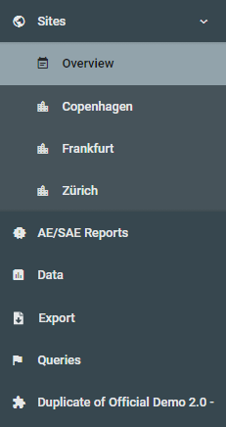
Figure 1

Depending on your access to the study, you can see one, some or all sites in the study. Whenever there is referred to accessing the site overview in this SOP, it is done as shown on Figure 1.

Subjects

Enrolment
When a subject is to be enrolled, a subject-profile must be created within SMART-TRIAL. This can be done in the site overview. The “site overview” can be accessed from the side menu (see Figure 1) by clicking “Sites” and selecting one of your sites.
In the site overview you will see the “New Subject” button (see Figure 2)
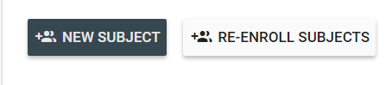
Figure 2
To enroll a subject, click on the "New Subject" button. From there, you can directly enroll subjects-profiles within a site, or enroll already created subject-profiles (if applicable).
This will bring up the window seen in Figure 3, these field will change depending on what attributes are required for the study.
<Edit this section to cohere with how one should enroll subjects in your study. Change the “enroll subject” figure 3 with your study specific screenshot. E.g. Should the subject ID adhere to a certain convention or are some attributes optional, but encouraged?>

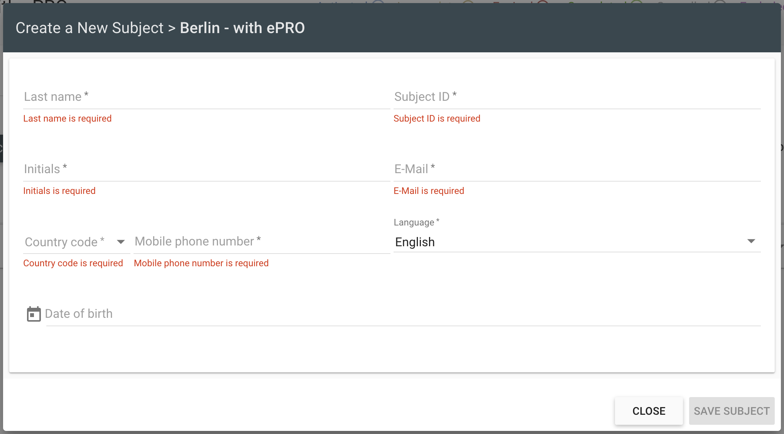
Figure 3

Discontinue subjects
To discontinue a subject, navigate to the site where the subject is enrolled, as shown in Figure 1, and click on “Discontinue”. This will bring up a box, where you can choose which subjects to discontinue.
If your study has discontinuation forms these will be shown – fill them out in accordance with your study protocol.

NOTE: You can always reenroll a discontinued subject, by clicking “Re-Enroll Subject”, see Figure 2.

NOTE: Should you discontinue a subject, all data that has been collected before discontinuing a subject is still stored and will be available when data is exported. All completed data events can be seen by changing the active filter in the site overview to “discontinued”, see Figure 5.

Sign off subjects
All events for a single subject can be signed off from the Site Overview Menu. To sign off a subject, go to the Site Overview Menu and under the “Actions” menu, press the three dots and a new menu will appear, click on the “Sign Off” and enter your SMART-TRIAL password. This will sign off the subject. Once the subject is signed off, a lock icon together with the date and name of collaborator who signed the subject off, will appear under the Subject ID, and the data events will be locked, see Figure 4.
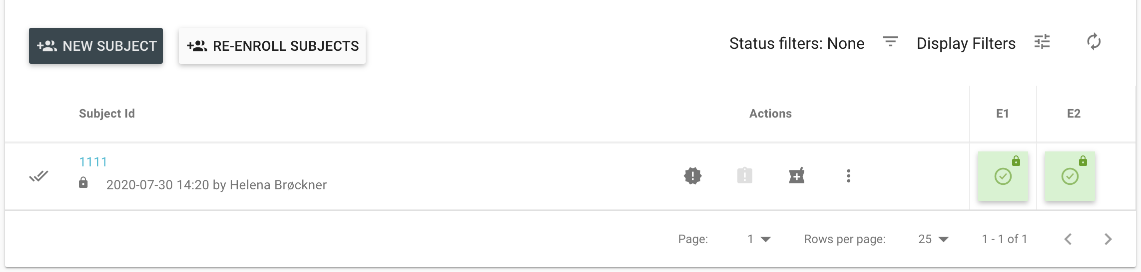
Figure 4
NOTE: Sign-off requires a special permission.

Excluded subjects
Subjects can get excluded if the study uses inclusion/exclusion forms. Should you give the wrong inclusion/exclusion answer causing the subject to get excluded you can always get them back in the study.
This is done by navigating to the site overview and changing “Status Filters”, as seen on Figure 5, to excluded. Next you change the answer to the question causing the exclusion, as seen in section 3.12. This will cause the subject to get included again and data collection can happen as usual.

Study Overview and Data input

Main Site Overview
Users responsible for reviewing subject status, or completing forms (case report forms), can access individual subject status for each site, by accessing the “Site-name” sub-menu under “Sites” in the left side menu, as seen on Figure 1.

In the site overview, you are shown a list of all subjects enrolled to the site, and individual “Data events” are shown for each subject as colored boxes. The status of each subject is represented by color of the box. By clicking onto the individual box, you can view detailed information for each data event/visit, fill out forms, print out forms, fill out forms for subjects (if required), or re-send forms to subjects.

In the top right (see Figure 5), you have a filter selector, which allows you to filter subjects by their status. This enables you to get a quick overview e.g. of all excluded subjects, or all completed subjects. By default, this filter is not on, which gives you an overview of all subjects.
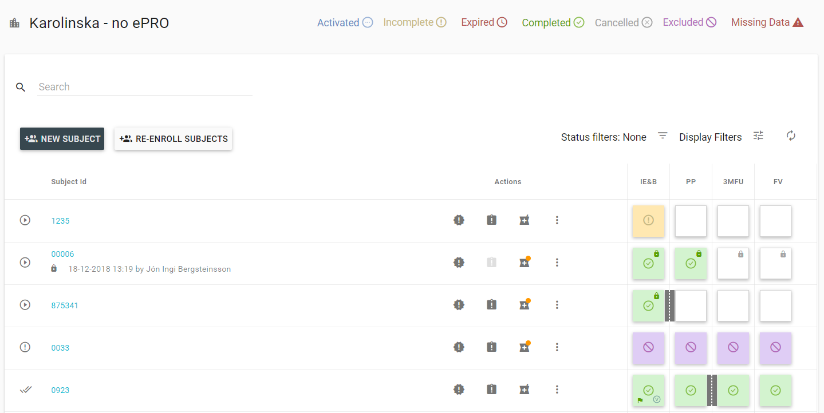

Figure 5
The different color codes, lets you know if a specific data event is either Activated, Incomplete or etc. (See Figure 5) Use this color or the filter to get a better overview of your data collection.
If a data event is Green, the data event is completed, and all mandatory data points have been answered in the data event.
If the field is Red, the data event has expired, because the deadline for the data event was exceeded.
Blue means that the data event has been activated and its possible to fill out the forms in the event.
If the data event is Orange the data event is incomplete, this can either be due to missing information or because the subject has left some of the questions in the form unanswered.
Purple means that the subject and their data event has been excluded from the study, already collected data is not lost. If the subjects get discontinued or data gathering is initiated in a data event later in the process, the data event get cancelled visualized with a Gray field.
A Green field with a red triangle indicates the status missing data, when additional questions have been added in an ongoing study, in such cases the particular data event containing the new question will have the status "missing data" for all subject who has already answered a form.
Under “Display Filters” you can customize the site overview to your liking, the customization is available until logout.
You can select which subject attributes you wish to see, e.g. if email, name and subject ID is collected, you can choose to only have subject ID shown. Likewise, you can choose which status icons you wish to see on the data events, e.g. if you are interested in seeing where there are open queries, you can select only the query icon.

AE/SAE and Medication notification
From the site overview you are able to access the subject’s AE/SAE Reports, Medication registration, or Medication Accounting. When an AE/SAE Report or Medication reports are available an orange dot will appear together with the icon in the list (See Figure 6).
To see how an AE/SAE or Medication report is created, see section 5 and 8.
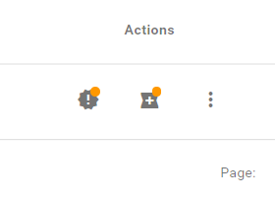
Figure 6

Locking Data Events – Freeze Answers
It’s possible to lock (freeze data) for individual data events. You can lock the data event at any time in the study. When a data event is locked, a lock icon will appear in the top right corner of the event. see Figure 7. To lock a data event, click on the specific data event and press “Lock Data Event”, see Figure 9.
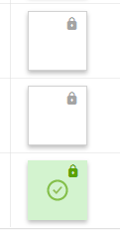
Figure 7

NOTE: The data event can be unlocked again is necessary.
NOTE: To lock and unlock data events, users require specific lock and unlock permission.

Collecting data – Subject Event
Subject event is one type of data event which SMART-TRIAL offers. Subject events require the subjects to answer the forms themselves and not by the healthcare professionals. There are three possible actions for a subject event, “send via email”, “send via email and SMS” and “do not send”.

For the two first mentioned actions, the subjects will receive either an email or an email and a SMS containing a link which the subjects can click on to fill out the questionnaires. The subjects can open this link in a web browser on any type of device. If the “do not send” action is applied for the subject event, then the subjects will not receive any link by email or SMS. This action can for instance be applied when the subjects shall fill out the questionnaires at the place of visit. Then it is possible for the study personnel to use e.g., a tablet and scan the QR code linked to the specific data event. This will give access to the questionnaires attached to the data event and it enables the subject to answer the questions on site. You can get access to the QR code in the site overview. Click on the data event of interest for the specific subject and click on “Show QR code/Link”. Now you can access the forms by either using the link or by scanning the QR-code on a device you want the subject to answer the forms in.
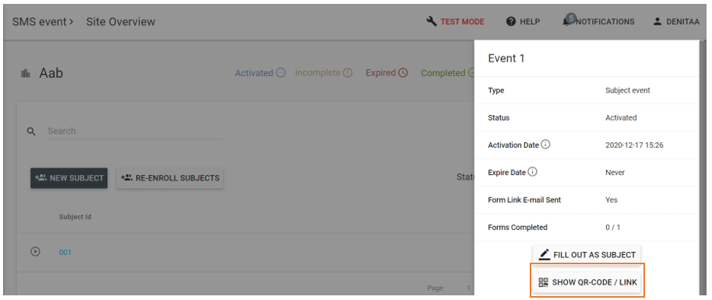
Figure 8

Collecting data – Visit event
Visit events are filled out by healthcare personnel at each site. When you are to fill out a form during a visit event, you must do this from the site overview (see section 3.1). Find the relevant subject, and click the visit event square, you will then be presented with a menu from the right. If the data event activation is set to manual, use this menu to click on ‘Start Data Event’, as seen on Figure 9.
If the data event has started, due to the event being activated either when a subject is enrolled or on a specific date, you can click on “fill out visit forms” to start collecting data.

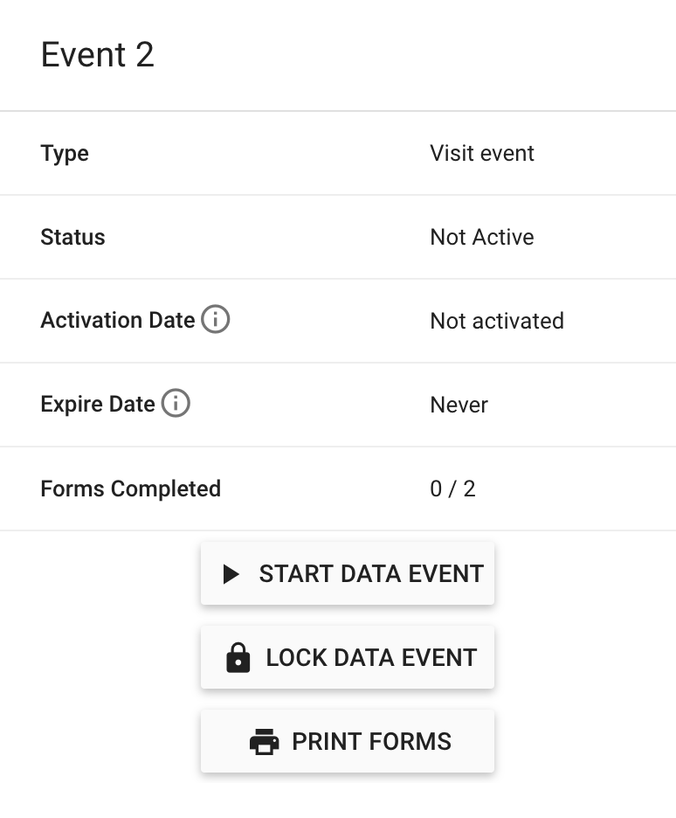
Figure 9

Activation of data events
Each data event is activated individually by one of the following types of activation: When a subject is enrolled, on a specific date, manual request or multiple activation. The “When enrolled” activation enables automatic activation of the data event when a subject is enrolled to the study. This means that the forms attached to the first data event can be accessed immediately when a subject is enrolled. To view if your data event is activated go to your site overview by using the side menu.
All subjects for the specific site are listed in this overview and the related data events are shown in the right.
When you enrol a new subject to the study the data event will automatically be activated, and the first square will turn blue. Click on the blue square to start collecting data.

The specific date activation activates a data event on a specific date selected by you. When you enrol a new subject, you will be asked to state a specific date for activation of the first data event.
NOTE: Remember that the dates for activation of data events must be in a chronological order, meaning that the second data event needs to be defined with a date that is after the first data event.

If manual request is the applied type data event activation you will have to activate the data events manually. Go to your site overview by using the left-side menu. You can manually start these data events by clicking on the white square. A new window will appear, select “Start Data Event” to activate the data event and to start collecting data.

Multiple activation allows you to collect the same data multiple times, for instance during hospitalisation, by activating data events several times. To activate multiple activation, access the site overview by using the left-side menu.
Multiple activation data events are marked with blue and a ‘+’ sign in the white square. Press the ‘+’ icon and activate the data event. This can be done as many times as necessary.

You can always reschedule a data event if you determine that data collection is not possible on the first scheduled date, this will however need the “reschedule” permission. You can reschedule a data event to be activated on today's date or a day in the future if you have the “Reschedule” permission. To reschedule a data event, go to the site overview and click on the data event of interest. A new window will open, click on the “Reschedule Data Event” button (see Figure 10).
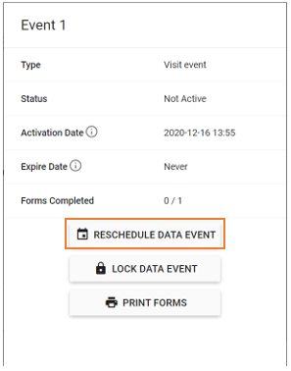
Figure 10
A new window will appear and here you need to specify the new activation date and if you want to apply the reschedulement for only the current data event or for all data events. If the reschedulement is applied for all subsequent data events, there will be a shift in the time of activation for all subsequent data events (see Figure 11). The shift is determined by the difference between the original activation date and the rescheduled activation date. If the difference for instance is +7 days this means that all data events will be activated 7 days later than each data event originally was scheduled to be activated at.
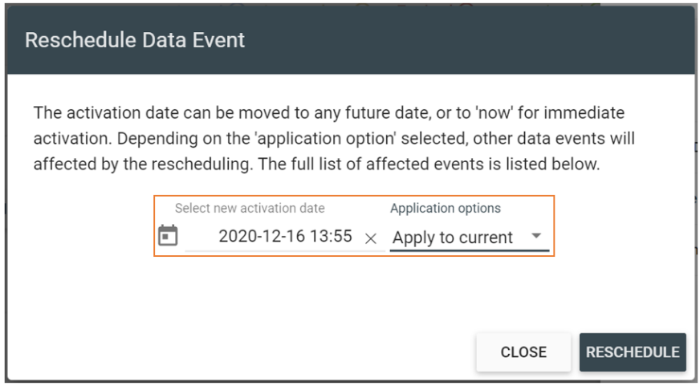
Figure 11

Jumping between forms in a visit event
When filling out forms during a visit event, it is possible to navigate between the different forms associated with the data event, should a form fit better with the workflow. This means you can jump between forms and fill them out in an order of your choice.

NOTE: You must click “Update and continue” to save any data input, if not, data will be lost.

Question Comments during visit events
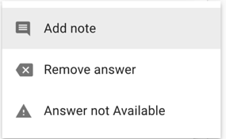
When filling data in a visit form, users can add individual comments to each question answer by clicking the menu button icon to the right of each question (see Figure 12). Here you can note anything that could be of relevance for the data input.
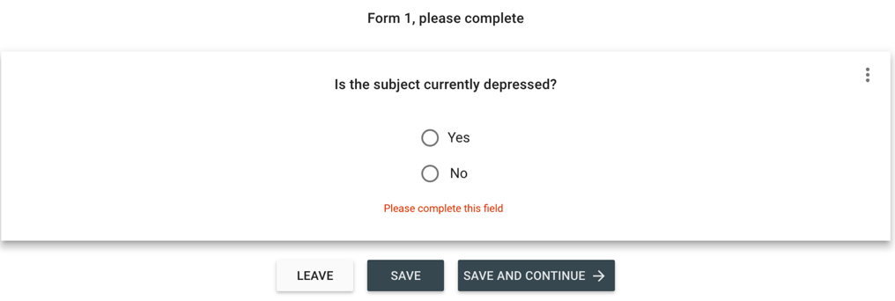
Figure 12

Remove selected answer
If you need to remove a selected answer to an optional question, e.g. if you have selected a choice from a multiple-choice question, you can remove your answer by clicking on the three dots in the top corner of the question (see Figure 12) and select “Remove Answer”.

Mark mandatory question answer as not available
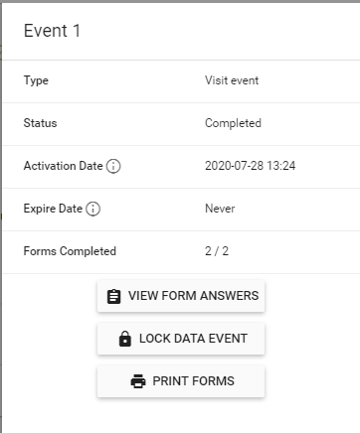
If you need to mark a mandatory question as “Not available” or as missing data, you can click on the three dots in the right corner of the question (See Figure 12) and select “Answer not available”.
Figure 13

Review subject/visit forms data
For reviewing form answers you can access completed forms for individual subjects via the site overview by clicking on the relevant data event squares and selecting “View Form Answers” (see Figure 13).

Change/edit answers/data
If data must be changed for an individual subject, this can be done while reviewing forms. While in the review data view, if you have sufficient permissions, you can edit the data within the form, by clicking “Edit Answers” in the top left menu of the form (see Figure 14).

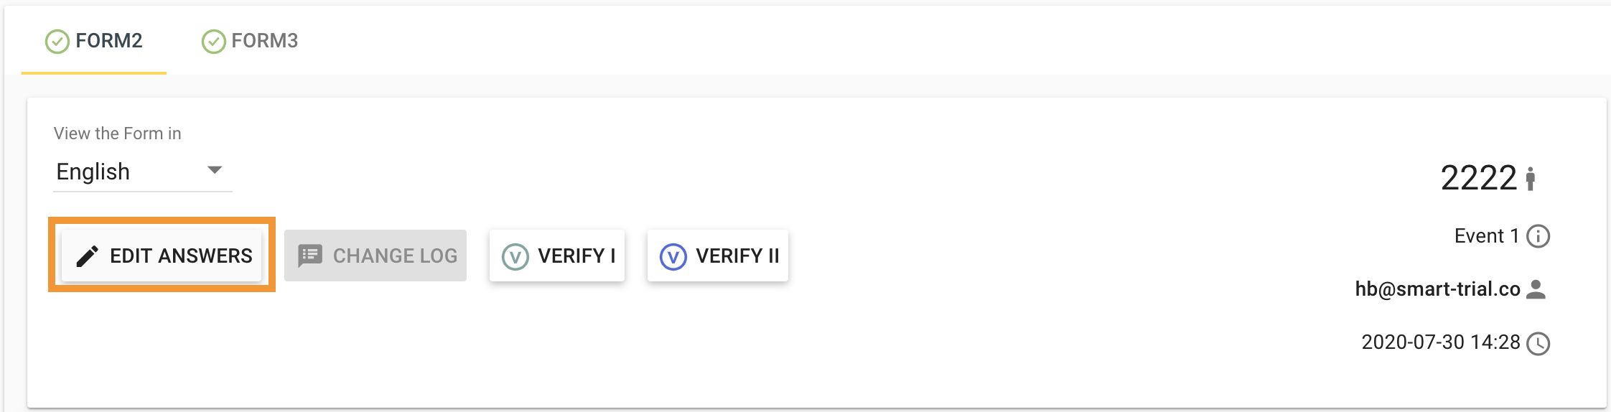
Figure 14
This button enables input change in every field of the form. When you have changed the relevant input data fields, you must click the “Update” button in the top or bottom of the form to save the changes. This requires you to submit a “reason for change” if you have either edited some form answers or if you have made changes on an incomplete data event, where you shall register the reason for why the change of data was performed. .
Should you regret any changes you have made, you can click the “Discard Changes” button, located same place as “Edit Answers” button.
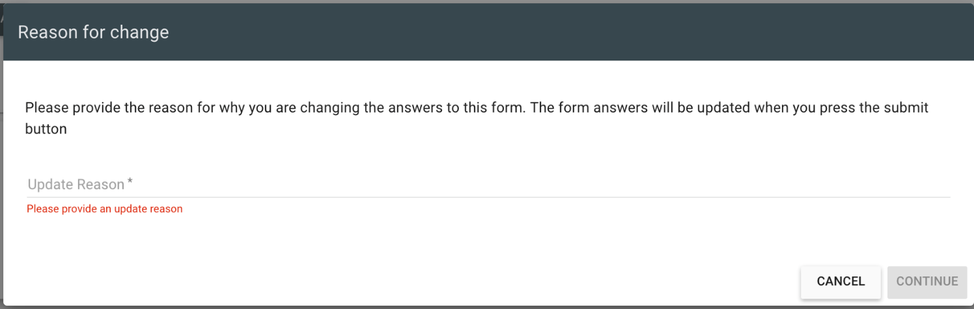
Figure 15
NOTE: any changes made to data or any study specific information is registered in the audit log of the study.

Overview of subjects and subject detailed information
From within the individual site overviews, you can access detailed information about each subject by clicking on the subject ID (see Figure 16).

Figure 16

Here you can access; detailed profile information, overview of their record history, medication (concomitant and IMP), medication accounting overview and any AE/SAE reports created for the subject. You can access any of these by clicking the tabs in as shown on Figure 17.

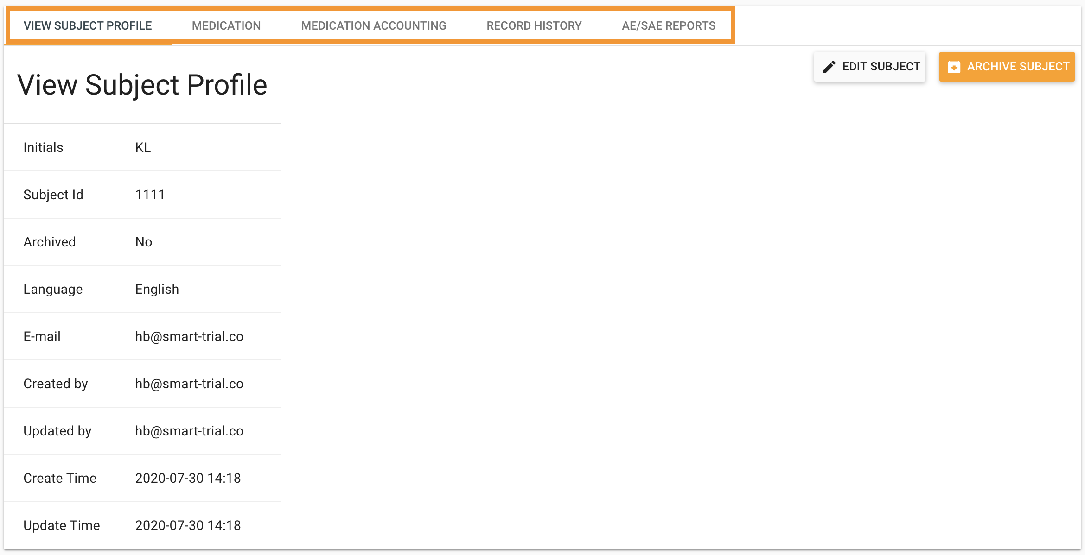
Figure 17
By clicking on “Record History”, you can gain access to a complete overview of all data collection events for the specific subject. From there, you can review each form answer by clicking the action button to the far right in the list (see Figure 18), where you can review each form for every specific data event (Figure 19).

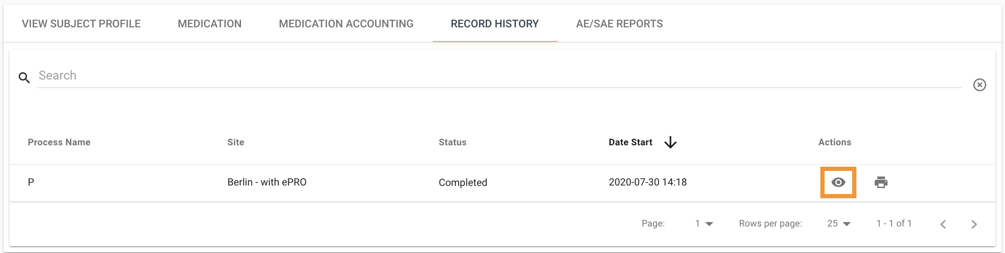
Figure 18
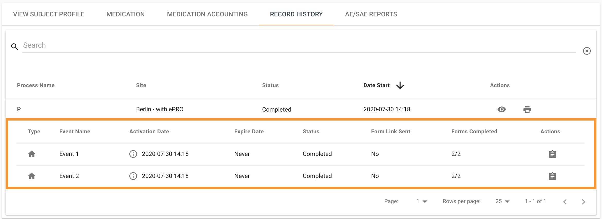
Figure 19

Queries

View queries / Review Patient/data event forms
[Add title of the responsible role e.g. Monitors]
For reviewing form answers you can access completed forms for the individual subjects via the site overview by clicking the relevant data event squares and selecting “View Form Answers” from the side menu (see Figure 20)
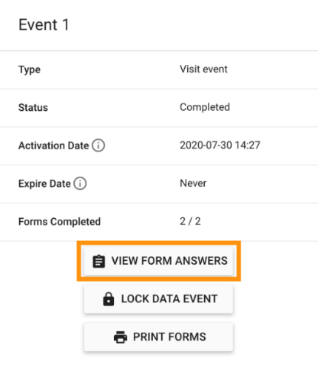
Figure 20
The Study Monitor will review and monitor the data being entered into the data events for each subject and will raise queries if needed, and these can be responded to by the site.

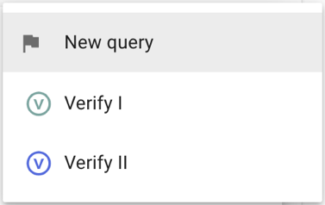
To create a query, click on the data event of interest and select “View Form Answers” to be redirected to the form answers. Click on the three dots which are found on the top right of each question/answer and select “New Query” and type in your query (see Figure 21).
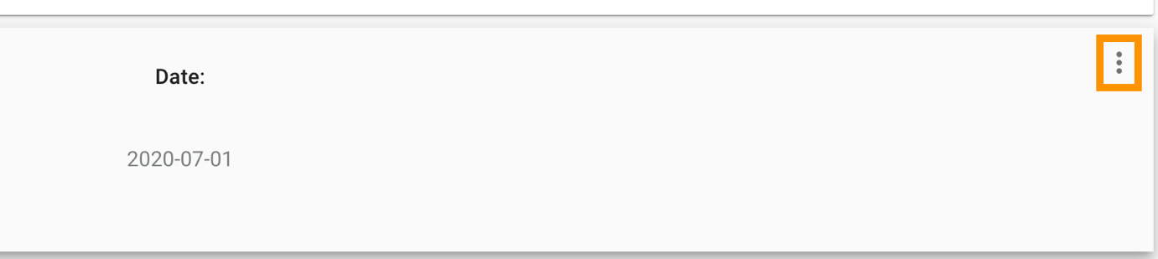
Figure 21
When a query has been raised you will see a flag icon in the data event box in the site overview.

Respond to queries
[Add title of the responsible role e.g. Site personnel or investigator]
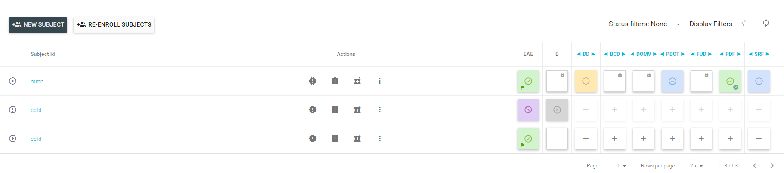
Open queries are visible in the site overview, as small flags placed on the data events, see Figure 22.
Shows that a query has been raised on this form
Figure 22

You can view all queries by using the left-side menu and clicking on “Queries” which will bring you to a query overview (see Figure 23 and Figure 24). Click on “Go to form” which is the first icon below ‘Actions. You can add filter options in the queries overview to sort the queries if needed. You can sort the queries based on who the queries are created by, the status of the queries (open, responded, closed), subject, sites, data events, specific forms or search for a specific query text.
Figure 23
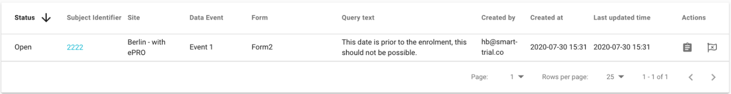
To respond to raised queries navigate to the question related to the query of interest either by clicking the relevant data event squares in the in the individual site overview and choose “View Form Answers” from the side menu (see Figure 20) or by using the complete list of queries.
Figure 24

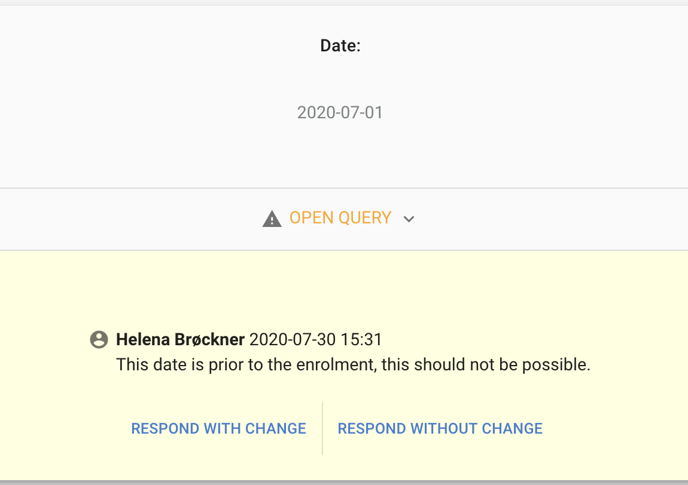
Figure 25

If the answer to the question is correct, click on the “Respond without a change“ button (see Figure 25). This will open a dialog box for you to apply a reason for declining the query, see Figure 26. If the answer is NOT correct, click on “Respond with change”. This will allow you to change the answer, followed by a requirement for applying a reponse to the query (see Figure 27). Then click the “submit comment” button at the bottom right of the box.

Figure 26

Figure 27

When queries have been resolved and closed you will see a “Responded query” below the answer to the question (see Figure 28).
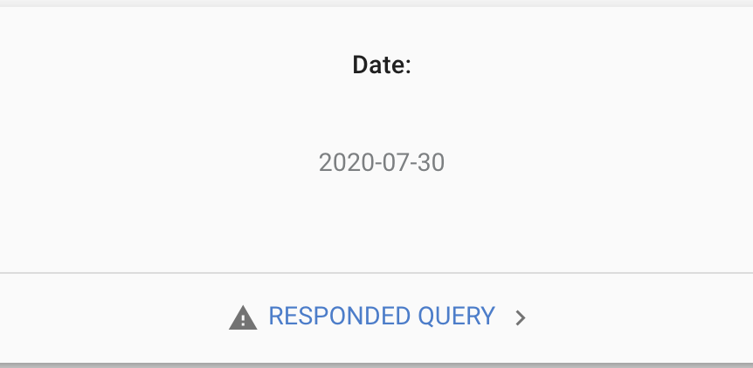
Figure 28
If you click on the “Responded query” this will show you the query and the answer(s) (see Figure 29).
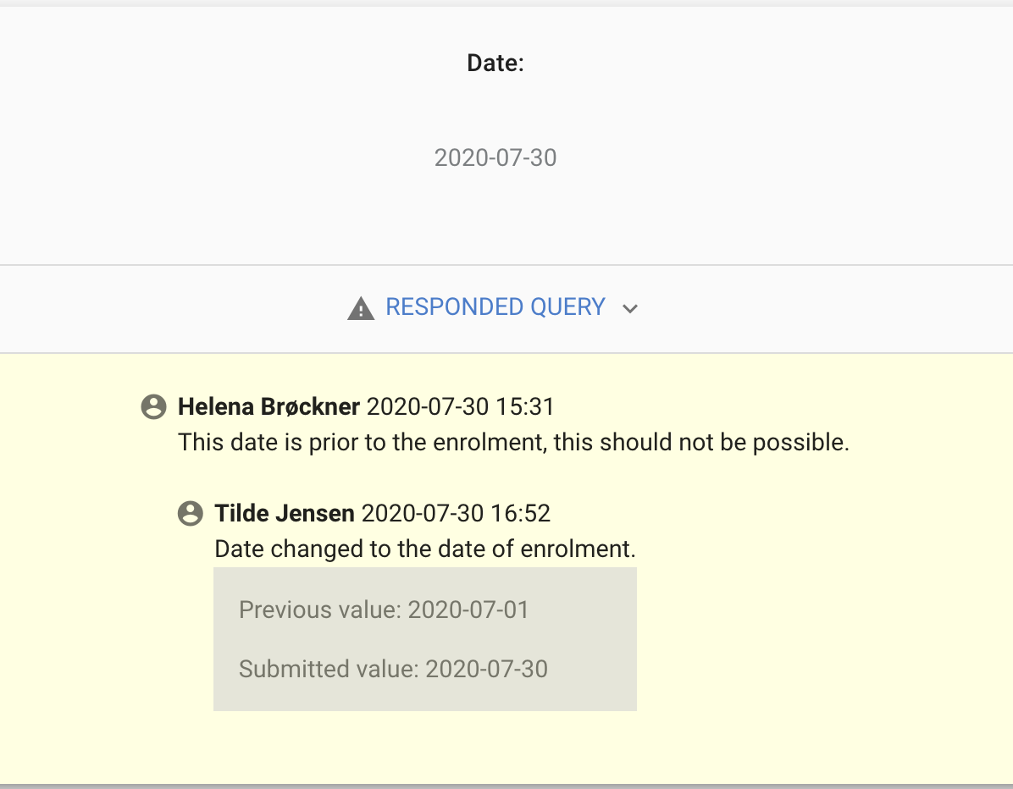
Figure 29

Medication and medication accounting
[THIS SECTION CAN BE REMOVED IF NOT RELEVANT]

Register IMP dose and concomitant medication
If you are to register IMP dose or concomitant medication, this can be done from within individual subject profiles. You can access the medication view from the “Site Overview” (see section 3.1) by clicking the medication button (see Figure 30) or by viewing the individual subject profile as done in section 3.13.
From the medication overview (see Figure 31) you can click “Add medication” to add a medication entry to the list, which can be either an IMP dosage entry or concomitant medication entry.
Figure 30
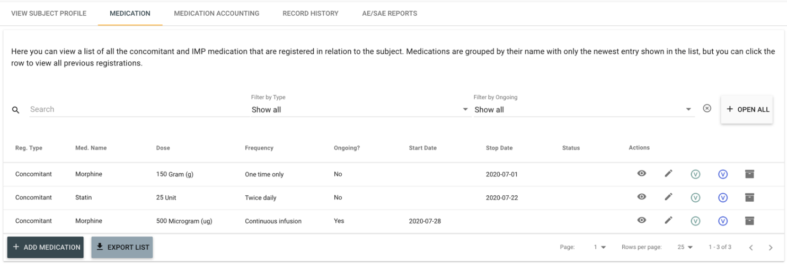
When adding a new medication entry to the list you must specify if this is an IMP or concomitant medicine registration.
Figure 31
Afterwards you must input: <the required fields (such as name of the medication, dose, unit, if ongoing etc.>, as seen on Figure 32.
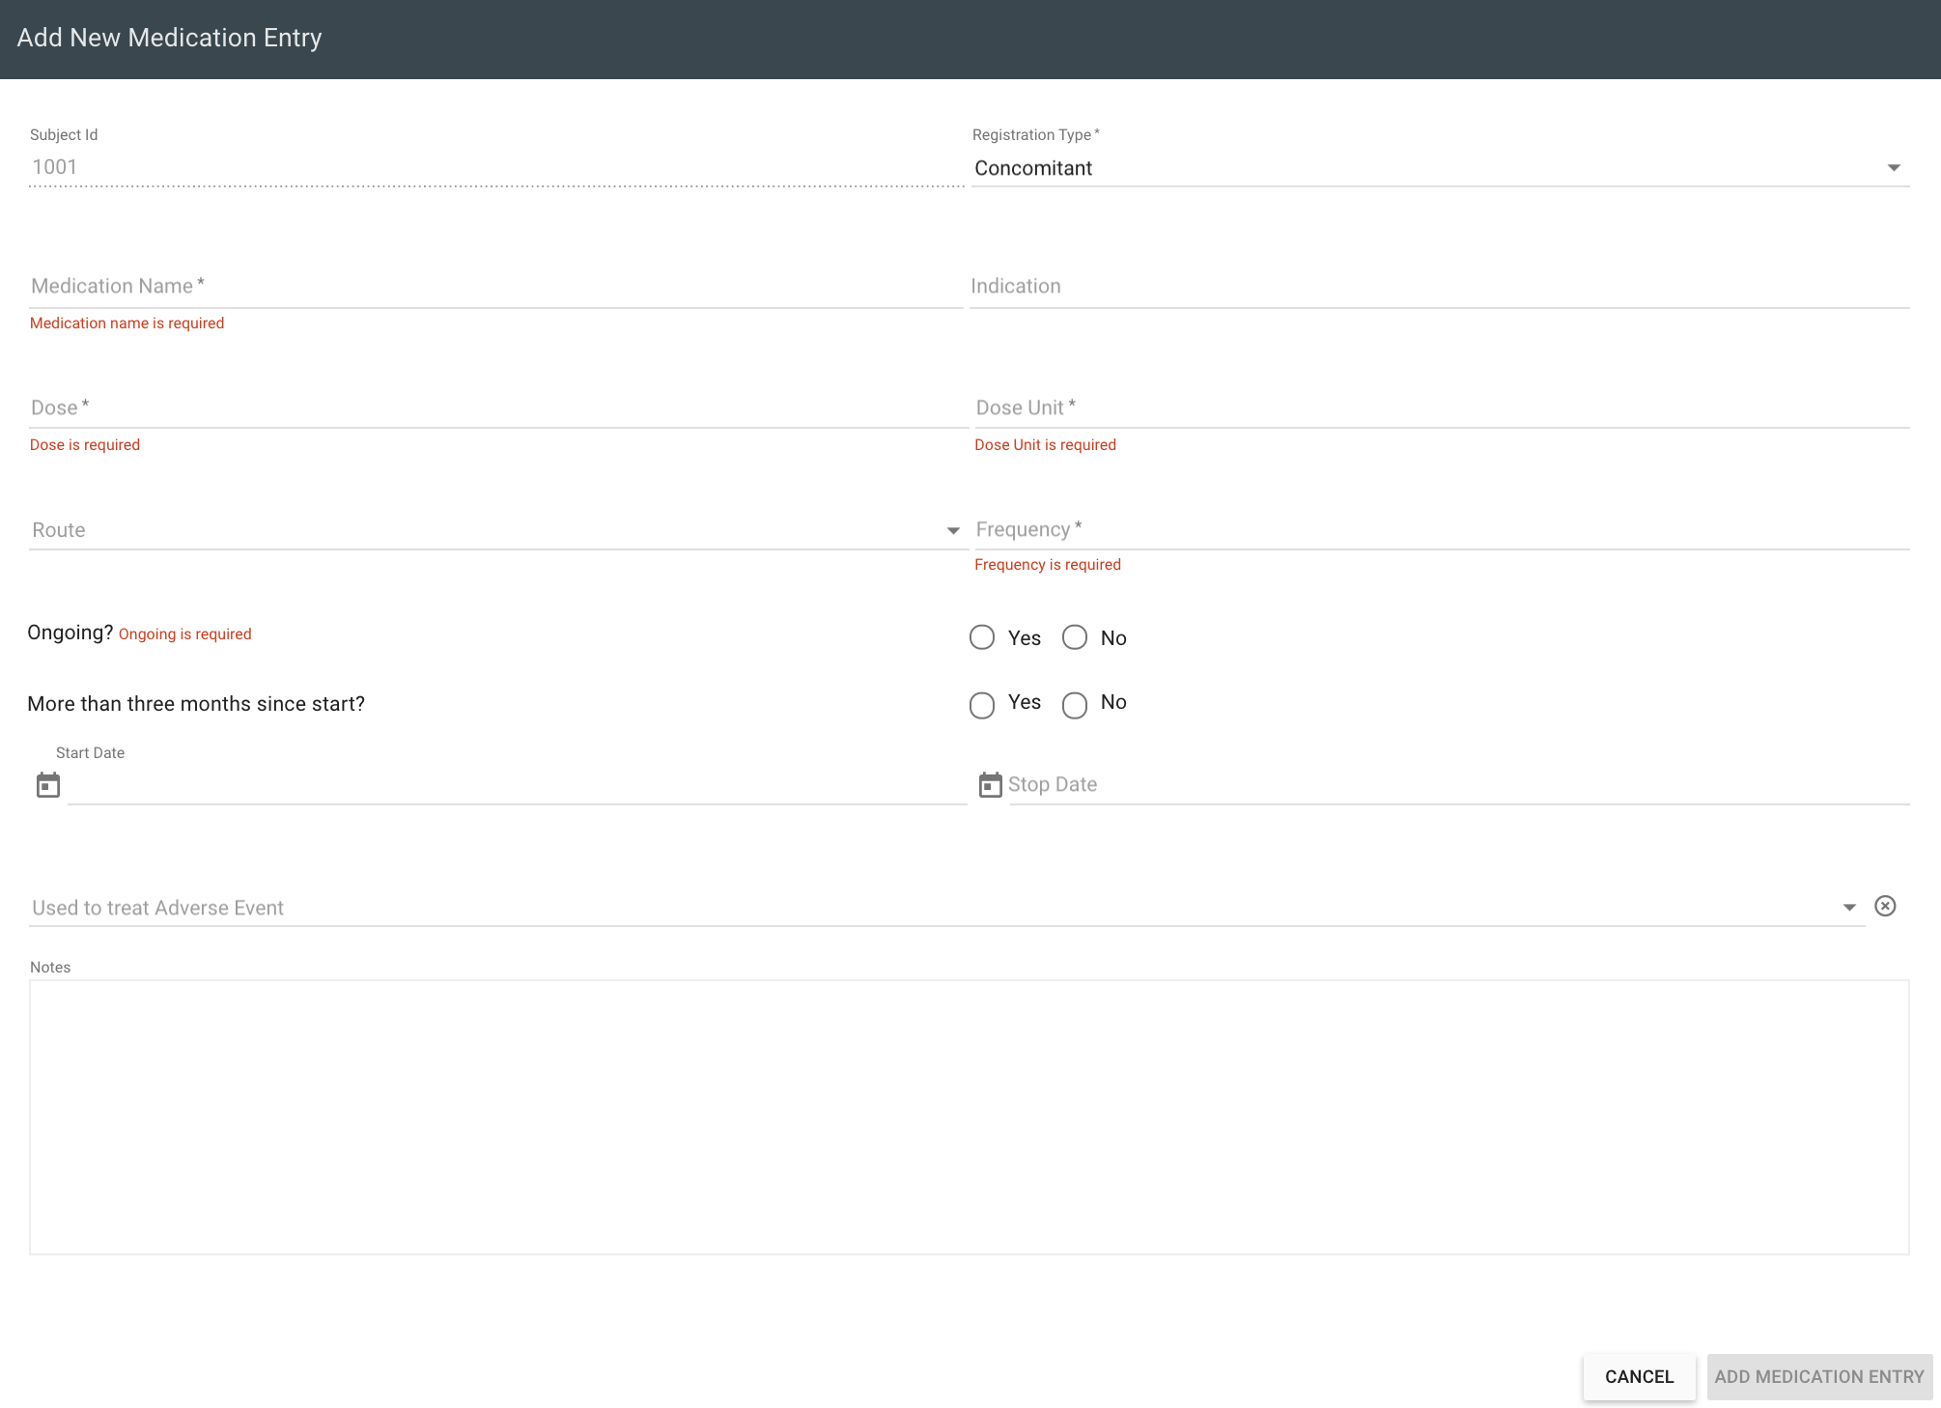
Figure 32
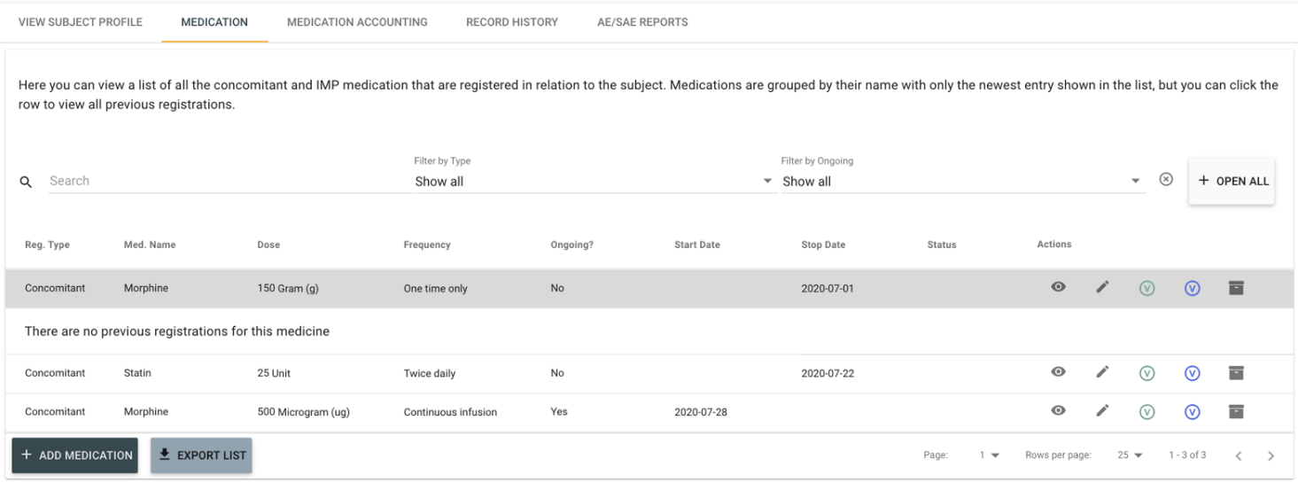
If multiple entries have been registered for the same medication, you can review the previous entries by clicking the individual medication entry rows in the list, this will present (see Figure 33). Individual medication entries can also be updated by clicking the action button to the far right in the list.
Figure 33
<Should there be any special instructions regarding registering medicine (IMP or concomitant) in your study, note it here. For example, there can be a sensitive naming convention to follow. Should you want to register insulin taken three times pr. day in a specific way; morning, noon and dinner, the naming convention could be “‘Rapid-Acting-Insulin-Brand’ morning” .>

IMP accounting
IMP accounting can be accessed from the subject profile (see Figure 17), by clicking on the “Medication Accounting” tab, see Figure 34.

Figure 34
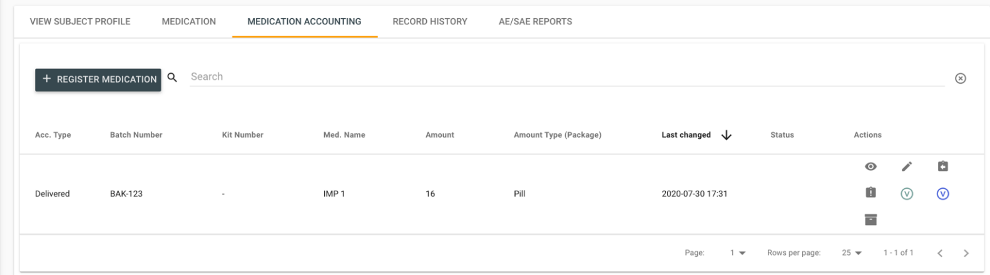
From the medication accounting view, you can handle all IMP accounting for individual subjects by clicking the “Register Medication”. This will show a dialog where you can specify the registration type (lost, returned, or delivered), medication name, the amount, batch number, and package type. The list overview will give you a quick indicator of all IMP accounting entries, see Figure 35.
Figure 35
<Should there be any special instructions regarding registering medication accounting in your study, note it in this section. I.e: If the study investigates insulin and the subject accidentally inject any insulin other than their prescribed, this could be registered as ‘returned’ with the naming convention “other insulin”.>

Discontinued events
[THIS SECTION CAN BE REMOVED IF NOT RELEVANT]

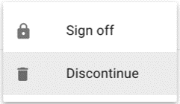
If discontinued events are supported in the study (see Figure 36), a form will appear when a subject is “Discontinued”. This will cancel all uncompleted data events, and mark the subject’s enrolment status as discontinued (the icon in the left side of the subject identifier will change), see Figure 37.
Figure 36
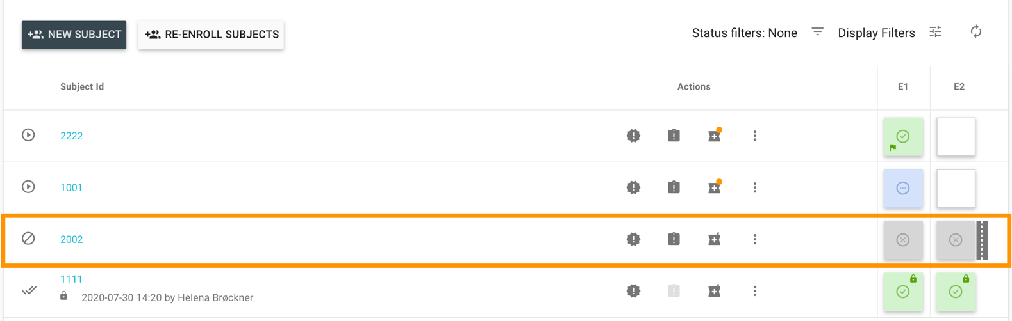
To review the Discontinue forms, go to the subject profile and find the forms under the “Record History”, see Figure 17.
Figure 37
NOTE: You can still access the data from filled-out data events and review answers.

Unscheduled events
[THIS SECTION CAN BE REMOVED IF NOT RELEVANT]

If process for a site supports unscheduled events, an additional icon will appear under the Actions menu in site overview, see Figure 38. From here unscheduled events can be registered for individual subjects. < Unscheduled event shall be registered… (describe how and when this shall be registered) >
Figure 38

A dialogue box will pop up (see Figure 39), here you should choose which optional forms (if any) to fill out during the unscheduled event, i.e. <Specify the forms to be completed for an unscheduled event, depending on the type of event>.
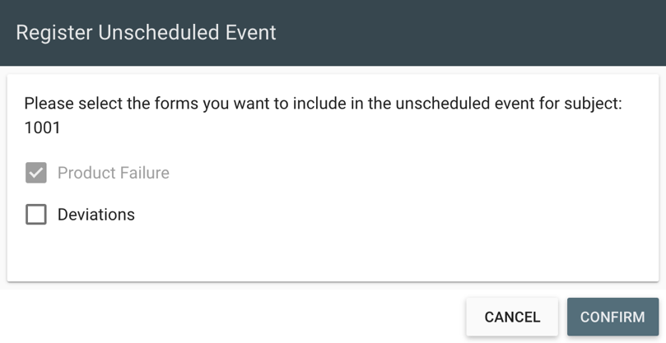

Figure 39
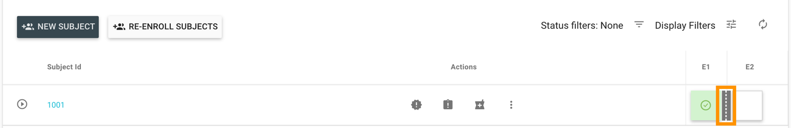
All unscheduled visits can be reviewed from the Site Overview menu where a grey marking will appear once a unscheduled events has been filled out, see Figure 40.
Figure 40

When clicking the grey marking, a menu will appear with the registration time, status and who registered the event and allows you to see the form and lock the event, see Figure 41.

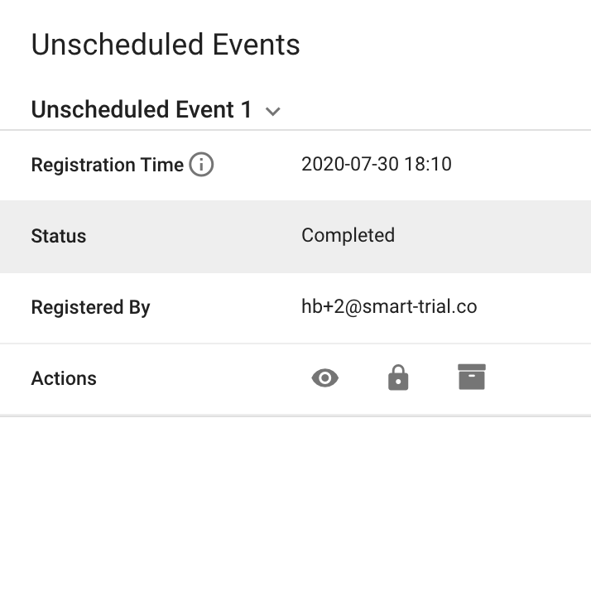
Figure 41

Adverse Event Reports
[THIS SECTION CAN BE REMOVED IF NOT RELEVANT]

Viewing Adverse Event Reports
To view all AE/SAE reports you have access to use the left side menu and click on “AE/SAE Reports”. You have the option to filter by site in the top right corner. ‘Status’ on Figure 42 shows which step the AE report is at. To view a specific AE/SAE click on the ‘view’ button (the eye). 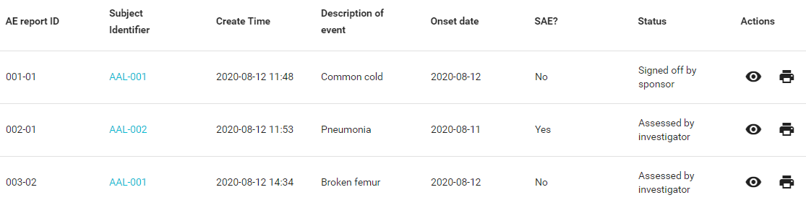
Figure 42

You can access all adverse event reports for a specific subject, by navigating to their profile and selecting the tab ‘AE/SAE Reports’

Registering and signing Adverse Event Reports
Depending on your role in the study you have a specific responsibility in the AE workflow. Please refer to the applicable section depending on your study role: Data entry personnel, Investigator, or Sponsor

For Data Entry Personnel
All collaborators with the ‘Report AE’ permission, can create Adverse Event reports for subjects. From the site overview, you can click the “View AE/SAE Reports” button from the action column for individual subjects (see Figure 43).
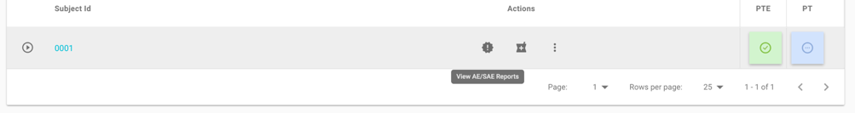
Figure 43
From there, you can click the “+ADD AE/SAE” button to create a new report. When reporting a new (S)AE a number of fields will be mandatory to fill in and it will not be possible to save the report until they have been filled. The ‘Report Event’ button will become active when the mandatory fields have been filled.

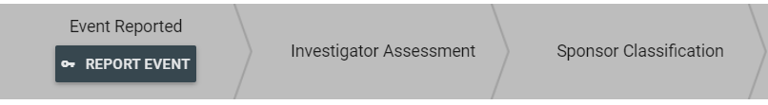
Figure 44
When clicking on ‘Report Event’ investigators and sponsors will be notified via in-app (for AE) and email (only for SAE), depending on the AE flow.

When viewing a reported (S)AE you can edit existing answers by clicking on ‘Edit Answers’ or continue the AE report flow, by clicking on the ‘Fill Out’ button if it is available. The availability depends on the step the AE report is at, and if there are any more fields reserved for data entry personnel.

For Investigators
Investigators are able to fill out investigator specific fields (marked by a gray/blue background) and are expected to partake in the adverse event flow at two steps: ‘Investigator Assessment’ and ‘Followed up’. Both these steps require investigator permissions to sign, and usually have fields that requires data input from the investigator.
To put the AE report into edit mode for the ‘Investigator Assessment’ step, click on ‘Fill out’ (see Figure 45)
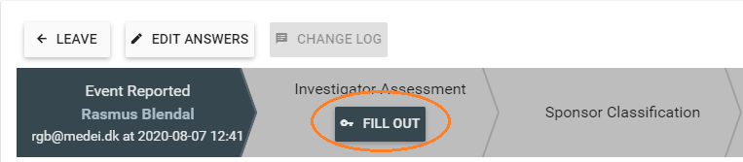
Figure 45

Once all mandatory fields for the ‘Investigator Assessment’ step have been filled out, you will be able to either “Save” or “Save & Sign”. In case you decide to just save, the fill out button will change to ‘Sign’.
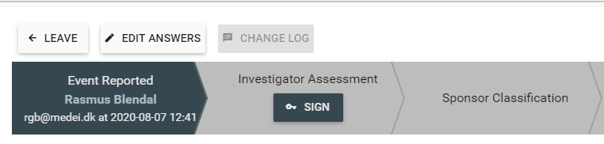
Figure 46
To sign a step, press the ‘Sign’ button and input your password. This will push the AE report to the next step, either ‘Sponsor Classification’ or ‘Followed up’.
Investigators will be notified within SMART-TRIAL when it is their turn to take action on an adverse event report, they have access to, and notified via email in case a SAE is reported for a subject on their site.

For Sponsors
Depending on the selected AE flow, sponsors are either involved or not at all.
If sponsor is involved, they partake in the AE report flow similarly to investigators. The AE report flow will indicate when it is the sponsors turn to act, by moving the ‘Fill Out’ (see Figure 45) button to the steps ‘Sponsor Classification’ or ‘Sponsor Sign Off’. Fields reserved for sponsors are marked with a yellow background.
Similar to investigators, sponsors are to sign the report when the mandatory fields have been filled out for one of the sponsor steps (see Figure 46).

Instructions for reporting AE/SAE, SUSAR, or USADE
<Explain in detail which type of events are considered as serious and should be registered, along with which questions shall be filled out, and how, for an AE/SAE, SUSAR, or USADE. You can also refer to protocol if this is detailed there. >

File Vault
[THIS SECTION CAN BE REMOVED IF NOT RELEVANT]

File Vault serves as additional storage capacity and is especially useful, when large data files are obtained during the study. File Vault supports all file types and helps organize the data by allowing you to specify the site, subject and data event the data file belongs to. The total storage capacity amounts to 1TB, and each datafile is limited to 1GB.

When you log in to File Vault, all stored data you have permission to access, will be displayed in the overview seen in Figure 47. To upload data, press the black cloud in the upper right corner:

Figure 47
Next step is to specify the specific site, subject and data event the data file is connected to, and lastly to choose the data file of interest (see Figure 48). If needed you can upload more files at once by selecting multiple files in your folder.

Figure 48
After the file has been uploaded it will appear in the overview shown in Figure 47.
From the overview you can manage all the previous uploaded data, allowing you to download the files by pressing the cloud icon next to the data file of interest, and to delete a data file by pressing the garbage can icon. Lastly, you can sort the data by site, subject and/or data event using the toggle filter, which is found in the upper right corner next to the uploading function, see Figure 49.

Figure 49
To keep track of actions, File Vault has an audit log enabling you to see what has been edited, when and by whom. The audit log button is found in the upper right corner (see Figure 49) and will bring you to an overview of all actions, displayed in a chronological order, see Figure 50.

Figure 50
To return to the data file overview click on “File Vault” in the upper left corner.

