<Insert Document Number>

SOP for Data Management in SMART-TRIAL in STUDY_NAME
<Organisation LOGO/NAME>

TABLE OF CONTENTS
I. Purpose 3
II. ProcesS 3
1. Account access 3
1.1. Create User Account 3
1.2. Log In 3
1.3. Edit Profile 4
1.4. Reset Password 4
1.5. Account Lock-out 4
1.6. Supported Browsers 5
2. Creating a Study 5
2.1. Create Forms 5
2.2. Create Processes 7
3. Validating and Releasing Studies in SMART-TRIAL 12
3.1. Setup and Manage Collaborators 12
3.2. Translations 13
3.3. Training of Sites and Collaborators 14
3.4. Launching your Study 14
3.5. Amendment Mode 14
3.6. Closing Your Study 15
4. Management of Study Data 16
4.1. Site Overview 16
4.2. Change Answers 19
4.3. Verification 20
4.4. Queries 22
4.5. Lock/Unlock Data Events 24
4.6. Sign Off Enrollment 24
4.7. Remove Data 25
4.8. Data Overview 26
4.9. Export Data 26
4.10. Audit Log 27
4.11. Study Notifications 28
5. Management of Subjects 28
5.1. Discontinue Subject 28
5.2. Undo Discontinue Subject 29
5.3. Exclude Subjects 29
5.4. Undo Accidental Exclusion 30

Purpose
The purpose of this document is to clarify the standard operating procedures for data management in SMART-TRIAL

ProcesS

Account access

Create User Account
Gain access and start using SMART-TRIAL by creating a personal account on https://www.smart-trial.co/signup. To create an account:
- Enter your first and last name, e-mail address, password, country code and mobile number. Choose a strong password containing at least 8 characters, one upper and one lower-case character, a number, and a special character. We recommend using all lower capitalization when entering your email. Please see Figure 1
- Read and accept the privacy policy and click on the “Create Account” button.
- A verification link will be sent to your email address, click on this link to get access to SMART-TRIAL. When the account has been confirmed you will be redirected to the login page. The verification email can sometimes end up in the “spam/other” folder so make sure to check these folders if you have not received the mail in your primary inbox.

NOTE: Be careful NOT to reveal your email address and password combination to anyone, since it used to identify you as a user of SMART-TRIAL.
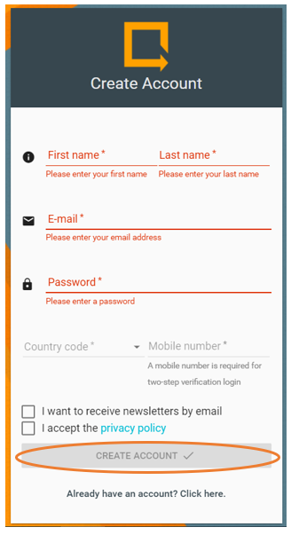
Figure 1

Log In
You can log in to your account through the top menu on www.smart-trial.com by clicking on the “Log In” tab or access the login site directly on https://app.smart-trial.co. The login system consists of a two-step verification.
- Enter your e-mail address and password to receive a verification code via SMS.
- Enter the received 4-digit code and click “Verify Login” to complete authentication. In some cases, the SMS can take a few minutes to arrive, however, if you do not receive a verification code via SMS, you can choose to receive the code by email address (Resend Code via E-mail) or phone-call (Resend Code via SMS). Please see Figure 2.
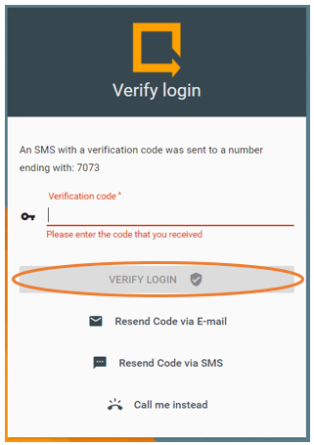
Figure 2

Edit Profile
You can manage your personal account information by clicking on your name in the top right corner and selecting “My profile”. Here you can enter account relevant information such as department, organization and address. By clicking on ‘Password’ in the top menu it is possible to update your password by entering your current and a new password and subsequently click the ‘Update Settings’ button. The third tab in the top menu, ‘Forms’ gives you access to your saved forms and these can be reused in other studies. Please see Figure 3.
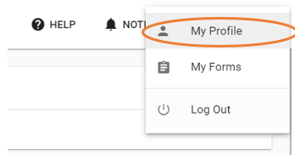
Figure 3

Reset Password
If you have forgotten or lost your password you can reset your password by clicking “Forgot your password?” on the main login screen or by clicking on this link https://app.smart-trial.co/#/authentication/forgot.
- Enter your email address exactly the way you signed up, as it is case sensitive, and click “Reset password” to receive instructions on how to reset your password.
- Click on the link in the instruction email and you will be redirected to a password reset page.
- Enter your new password and click on “Update Password”. Your password will now be updated and you will be redirected to the login page where you can login with your new password.

Account Lock-out
Account lock-out happens after 5 wrong attempts to log in to your account. Please contact support@smart-trial.co if your account is locked and we will reopen your account. If you have forgotten your password and have not had 5 wrong login attempts, please reset your password.

Supported Browsers
Use SMART-TRIAL through one of the following supported browsers:
- Google Chrome version 50 and above
- Mozilla Firefox version 50 and above
- Microsoft Edge version 38 and above
- Safari version 10 and above
- Internet Explorer 11 (Not recommended)

Use of SMART-TRIAL on Internet Explorer is not recommended due to performance and security issues. Furthermore, we recommend using the newest version of the above stated browsers to ensure the most updated security patches and performance level.

Creating a Study

Create Forms
The first step of creating a study is creating all forms necessary for the data collection. Creation of forms includes a variety of functions related to question visibility and the availability of the questions.

Mandatory/Optional
When creating a new question, you can choose to enable the ‘Mandatory Question” button if your subjects MUST answer the question. If you choose not to activate this button it is not a requirement to answer the question and the subject can choose to skip the question. Please see Figure 4.
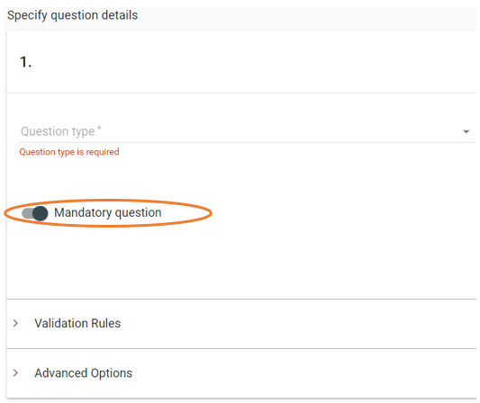
Figure 4

Show Rule
This function allows you to determine which questions your respondents can see next and irrelevant questions can be hidden for the respondent. The question with an enabled show rule will only be shown to the subject if the previous question is answered as defined in the show rule. In the edit form view you can add a show rule by:
- Click on the ‘Show Rule’ tab followed by clicking “+ Add show rule”. Please see Figure 5.
- Now, specify under which conditions this question should be visible by selecting one or more of the prior questions you would like this question's visibility to be dependent on.
- If you need this question's visibility to be dependent on more than one previous question, click “+ Add show rule” to add additional show rules.
NOTE: It is only possible to add a show rule if previous questions within the form has been of the following type: “Yes/No”, “Multiple Choice” or “Multiple Response”
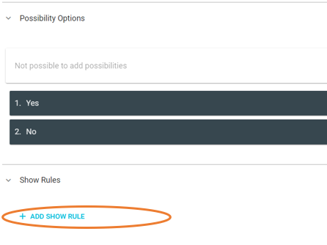
Figure 5

Validation Rules
A variety of question types support the validation rules and these are the following: “Number”, “Date”, “Date and Time”, “Specific Time”, “Duration”, “Multiple Choice”, “Multiple Response”, “Yes/No”, free text, and “5 level smiley scale”.
The application of validation rules can have one out of the following three consequences when broken:
- Block Answer: The form answers cannot be saved as long as the answer breaks the defined rule.
- Show Warning: The form answers can be saved but an orange-coloured warning will be shown to alert the user. The warning can either be specified by the user or a default text will be shown.
- Generate Query: A query on the answer will be created and anyone with the “Query Permission” will be notified.

To add a validation rule click on “Validation rules”, to open the drop-down tab, please see Figure 6.
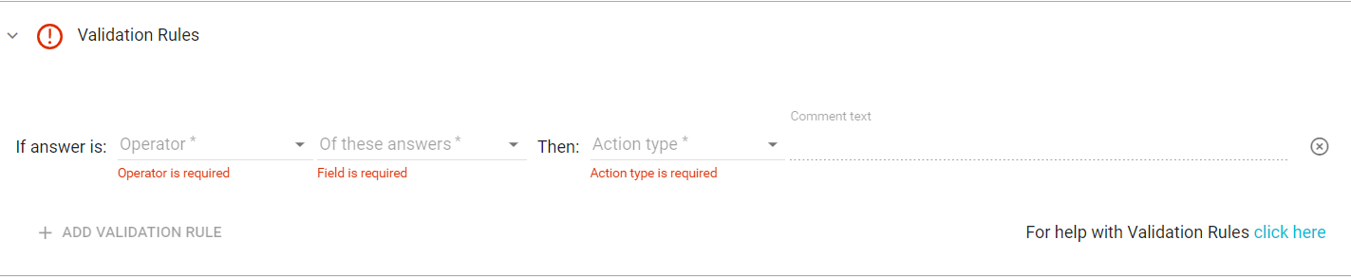
Figure 6

The validation rule consists of different inputs depending on the type of question.
Examples:
- Question type “Number”: 4 input parameters one of them is optional. In the first input you define the operator that will break the validation rule. Subsequently, you must specify the value the question answer should be compared to followed by the type of action you want to be performed when the rule is broken. The comment text is optional but this field can be used to customize the text shown for the study personnel when the rule is broken.
- Question type “Multiple response”: 2 input parameters. You can define the minimum and maximum number of answers.
- Question type “Free text”: 2 input parameters. You can limit the number of characters by specifying the minimum and maximum length of the free text.

Export Labels
Create your own export labels to your questions to enhance the overview in the export file or image chart data. If you do not use your own custom labels, SMART-TRIAL will automatically create unique labels when exporting. You can also choose to use both. SMART-TRIAL’s labeling for the first data event, form 1, question 1 is indicated as follows E1_F1_Q1. If you add an export label to your question the ‘Q1’ will change to your custom text.
Figure 7
To add an export label to your question:
- Click “Advanced Options” to open the drop-down menu.
- Specify your own custom label in the ‘Export Label” field, please see Figure 7.
- The export label is saved, when you save the form.
You can also define a custom export label for data events, the procedure is similar to the question labels. Find your data event in the process, click “Advanced Settings” and specify your export label.
NOTE: The system will give you a warning if the form or data event export label is not unique.

Module Reference

This function can be used when creating forms to link to SMART-TRIAL’s other modules. There can be created module references to unscheduled events (used for e.g.: protocol deviation and device deficiency), adverse event reports and medication. These references will redirect the user to a different form, and after the reference form is filled in, the user will be directed back to the original form they came from. These references can be hidden or shown if a specific answer is given by the use of ‘Show Rules’.

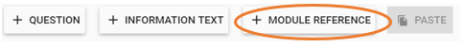
Figure 8
To create a module reference:
- Enter the form of interest and click “+ Module Reference”, please see Figure 8.
- Select the type of reference and specify the reference details.
- To add a show rule click on “Show Rules” and follow the instructions in 2.1.2.
- Specify which answer the subject has to select in order to make the module reference visible.

Create Processes
When all necessary forms are created the next step is to create a process. A process is the “timeline” of your study and you define the different data events you want and the created forms are attached to these data events. Three different types of data events exist in SMART-TRIAL and the relevance of using each of these varies with the type of study.

Types of Data Events
- Visit Event: This data event is relevant to use when the purpose of the study is associated with collecting data by using eCRF. Visit event allows healthcare professionals to collect and enter data from a subject. Usually it is in relation with a subject visit at the defined sites. To create a visit event:
  - Click on “Create processes” in the top menu in the building view.
  - Click on the “+ New Process” tab and enter the process details followed by clicking “+ Add Data Event”.
  - Select “Visit event” as the type of data event and you will now be able to attach the event relevant forms. You can rearrange the order of these forms by dragging and dropping.
  - Name the data event
  - Lastly choose an appropriate type of activation.
  - To add additional data events click on the “+ Add Data Event” otherwise save your process including the created data events by clicking on “Save Process”.

- Subject Event: This type of data event is relevant to apply when the investigation purpose concerns an ePRO or survey aiming to make the subjects answer the questions themselves. Subject event triggers an email or a SMS to be sent out to the subjects containing a link to the forms. To create a subject event:
  - Click on “Create processes” in the top menu in the building view.
  - Click on the “+ New Process” tab and enter the process details followed by clicking “+ Add Data Event”.
  - Select “Subject Event” in the ‘type’ field
  - Name the data event
  - Attach the relevant forms and control the order of the forms by dragging and dropping them in the interested order. Enable the “Force fill-out order” button if you want to ensure that the subjects answers the forms in the order you defined.
  - Choose an appropriate type of activation.
  - Select if you want to send the link in an email or as an email and as an SMS.
  - To add additional data events click on the “+ Add Data Event” otherwise save your process including the created data events by clicking on “Save Process”.
NOTE: Subject event is only applicable when email or mobile number is selected as mandatory subject attributes.

- Information Event: This type of data event can be used to inform or provide contextual information. Information events do not have the function of attaching forms since this data event is for informational purposes only. To create an information event:
  - Click on “Create processes” in the top menu in the building view.
  - Click on the “+ New Process” tab and enter the process details followed by clicking “+ Add Data Event”.
  - Select “Information Event” in the ‘type’ field
  - Name the data event
  - Choose an appropriate type of activation.
  - Select if you want to send the link in an email or as an email and as an SMS.
  - Lastly, specify the email subject line and the content that will be sent to the subjects. The subject line is what the subject will see in the inbox. It is a good idea to personalise the email content to form an incentive to respond. Remember to add a link to the forms by clicking XX in the upper right corner of the text field.
  - To add additional data events click on the “+ Add Data Event” otherwise save your process including the created data events by clicking on “Save Process”.
NOTE: Be aware of what you write in the email subject line and the email content in order to avoid spam filters and the email not being received by subjects. Text in capital letters and strange links will for instance activate these spam filters

Enrollment Methods
SMART-TRIAL consists of three different enrollment methods and these can be applied in accordance to which one is the most appropriate taking the study purpose and design into consideration. The study must be in either test-mode (enroll up to 5 subjects) or in collecting data-mode in order to enroll subjects.
- Enroll a new subject within SMART-TRIAL: This is performed by creating a subject-profile for each of the subjects in the study:
  - Click on your study in the study overview and click on “Test Study” to test your setup or on “Start Study” to start your study and collect data, please see Figure 9.
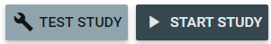
Figure 9
- Use the left-side menu to access sites and select one of your sites, please see Figure 10.
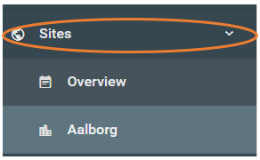
Figure 10
- Click on “+ New Subject” and a “Create a new subject” window will appear for your specific site. The field in this window will change depending on what attributes you previously selected as required for the study. Fill out the fields and click on the “Save Subject” button. Please see Figure 11.
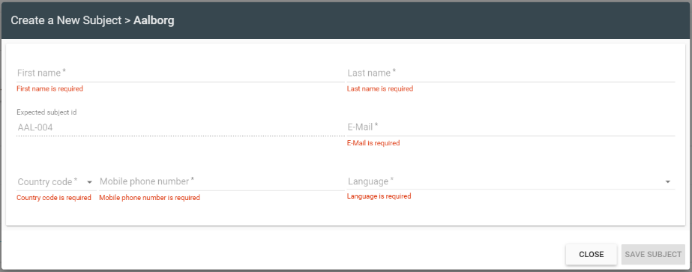
Figure 11
- Public Sign Up: This method enables the subjects to enroll themselves through a public signup link which can be shared using social media or other similar methods. The subject can create a profile by entering required information (first name, last name, e-mail address) and answer the forms assigned to the first data event. To enable public signup:
  - Make sure that your study is in build mode.
  - Go to “Processes” and click on the “Edit Process” button.
  - Click on “Advanced Settings” and enable “Public Registration” to create public signup links for each of your sites. Please see Figure 12.

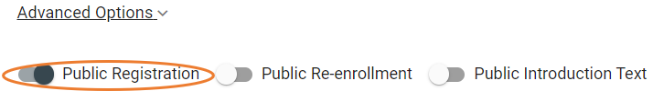
Figure 12
- To view the actual link, go to “Process” and click on “View Process”. Please see Figure 13.

Figure 13
- A new window will appear and here you can click on “View Sign Up Link” to view the different language specific links.
- Enroll from foreign systems (API)
  - The “Sign up subject” resource
  - The API key (Enable “API access” on your study)
The resource is enabled in SMART-TRIAL when setting up the process, under “Advanced Settings”.

Activation of Data Events
Each data event must be activated individually to enable data collection. If your study has multiple data events, you must choose how to activate each one of them. SMART-TRIAL provides different types of activation and your desired type of activation can be selected when specifying the process.

- When enrolled: This type of data activation enables automatic activation of the data event when a subject is enrolled to the study. This means that the forms attached to the first data event can be accessed immediately when a subject is enrolled. To view if your data event is activated:
  - Go to your site overview by using the side menu.
  - All of your subjects for the specific site are listed in this overview and the related data events are shown in the right.
  - When you enroll a new subject to the study the data event will automatically be activated and the first square will turn blue.
  - Click on the blue square to start collecting data, see Figure 14.
Figure 14
- Specific Date: This type of activation lets you activate a data event on a specific date chosen by you. When you enroll a new subject you will be asked to state a specific date for activation of the first data event.
NOTE: Remember that the dates for activation of data events must be in a chronological order, meaning that the second data event needs to be defined with a date that is after the first data event.
- Manual Request: If this is your preferred type of activation you will have to activate the data events manually.
  - Go to your site overview by using the left-side menu.
  - All of your subjects for the specific site are listed in this overview and the related data events are shown in the right.
  - You can manually start these data events by clicking on the white square. A new window will appear, here you should click on “Start Data Event” allowing you to start collecting data, see Figure 15.
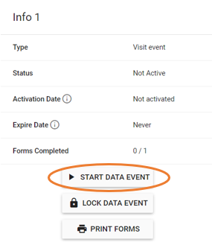
Figure 15

- Multiple activation: This type of activation is only possible when ‘Manuel Request’ is applied as the data event activation method. Multiple activation allows you to collect the same data multiple times, for instance during hospitalisation, by activating data events several times. To enable multiple activation:
  - Select Manuel Request as the activation method when creating your processes.
  - A new function will appear below the activation drop-down.
  - Click on “Multiple Activation” and enable this activation method for the data event of interest.
  - Access the site overview by using the left-side menu.
  - Multiple activation data events are marked with blue and a ‘+’ sign in the white square.
  - Press the ‘+’ icon and activate the data event, see Figure 16. This can be done as many times as necessary.
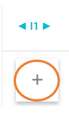
Figure 16
- Previous Data Event Start: This activation will be applicable after creating one data event. If this activation type is applied, then the specific data event will be activated X number of days/hours after the activation of the previous data event. To use this activation:
  - Click on “+ Add data event” to add another data event.
  - Select “Previous data event start” as the activation method for this data event.
  - Specify the number of hours or days you want this event to start after the previous data event.
- Previous Data Event Completed: This activation type will be available after one data event is created. The specific data event will be activated X number of hours or days after the completion of the previous data event. This means that this data event is dependent on the subjects/healthcare personnel to fill out the previous questionnaires. To apply this activation:
  - Click on “+ Add data event” to add another data event.
  - Select “Previous data event completed” as the activation method for this data event.
  - Specify the number of hours or days you want this event to start after the previous data event is completed.

Validating and Releasing Studies in SMART-TRIAL

Setup and Manage Collaborators
In SMART-TRIAL you can add other users to work together on your study. Collaborators can have different permissions in the system according to their roles and responsibilities in the study. The permissions control what your collaborators have access to, can see, edit and fill out. SMART-TRIAL’s help-site provides a template which can be used to plan and determine different collaborator’s permissions in advance, this can be found by accessing the following link: https://help.smart-trial.co/display/HELPPlayground/Document+Templates.

Adding Collaborators
- Enter your study by clicking on your study name in the left-side menu.
- Use the left-side menu to access the “Collaborators” overview.
- Click on the “Add collaborators” button and a new window will open, see Figure 17.
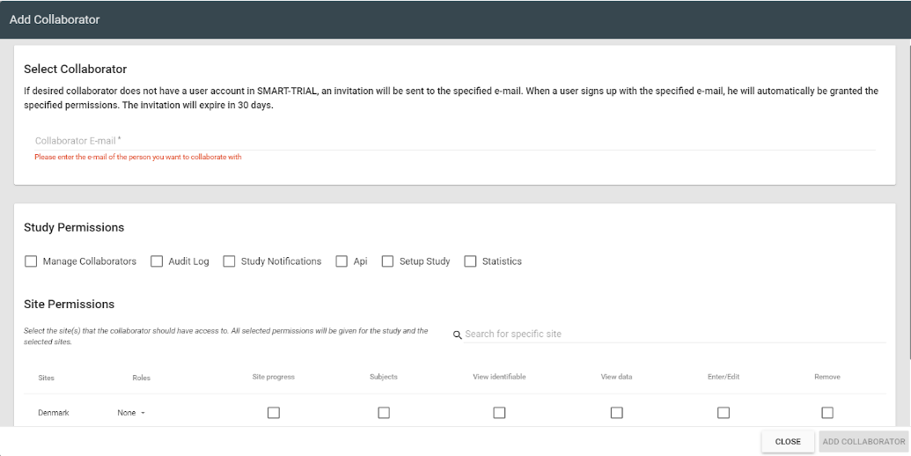
Figure 17
- Enter the email address of the collaborator
  - If the collaborator is not already a user of SMART-TRIAL, they will receive an invitation on email to create an account. The user will be granted all the specified permissions when the account is created in the system.
- Specify which ‘Study Permissions’ the collaborator should be granted. The different controls connected to the permissions can be seen by hovering the mouse cursor over the individual permissions.
- Select which sites the collaborator should have access to in the “Site Permissions”.
- Subsequently define the role of the collaborator, this will automatically enable specific permissions to the right. These permissions can, however, be adjusted if needed. The help-site consists of a schema that defines which site permissions each role has. Explanations to these permissions are also available on the following link: https://help.smart-trial.co/display/HELPPlayground/Managing+Collaborators+and+Permissions
- Finally, click “Add Collaborator” to add the user to your study.

Removal of Permissions
It is possible to manage the permissions for collaborators in the study at any time. You can remove or add permissions in the collaborators overview.
- Enter your study by clicking on your study name in the left-side menu.
- Use the left-side menu to access the “Collaborators” overview. The collaborators in your study should be listed in this overview.
- Click on the “Edit” icon below ‘Actions’.
- Now you can remove any permission by clicking on it and removing the tick.

Personal Identifiable Data
The GCP regulations require companies to protect the privacy of their subjects. It is therefore important that the study personnel follows the company policy in relation to access to personal identifiable information in SMART-TRIAL.

Translations
If your study takes place in multiple countries it might be a good solution to make the forms and processes available in the native languages of the subjects. In such a situation you can use SMART-TRIAL’s translation module. Before translating make sure that you have set up your study fully in the primary language, as every time you add something new, for instance a form, it has to be translated. Otherwise, the new form will be shown in the primary language. The translation module provides you an interface that allows you to translate the actual context of your study. Fixed buttons and menus in the part where the subject fills out the answers will automatically be translated by SMART-TRIAL. The formulated questions themselves must be translated manually by a qualified translator. Lastly ensure that the translations for each language looks like how it is supposed to.
- Click on your study name in the left-side menu and enter the “Translations” overview, see Figure 18. In this view you can see the primary and all the secondary languages of the study.
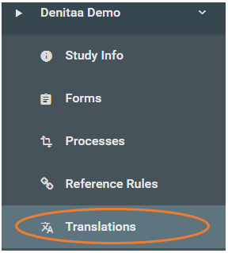
Figure 18
- The translation process of each is stated for each language. “Total” specifies the number of elements that has to be translated, this is everything from possibility text to question text.
- To translate a form click on the “Translate Forms” icon below ‘Actions’ and select the form you want to translate, see Figure 19. You can translate one form at a time.
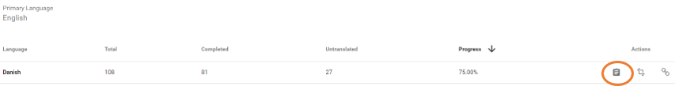
Figure 19
- To translate a process click on the “Translate processes” icon below ‘Actions’ and select the process you want to translate, see Figure 20. If you only have one process it will be pre-selected automatically. Subsequently, select the data events you want to translate.
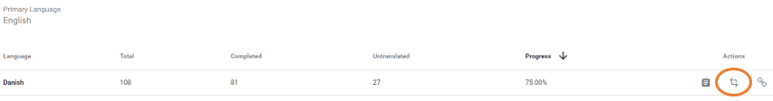
Figure 20

Translations for Public Signup
Public signup links have language specific links meaning that each language the study supports has its own link. A secondary language does not have to be 100% translated to be available in the public fill out part of SMART-TRIAL. Instead the default public sign up and fill out pages will show the primary language if translations for the selected language are not available. BUT any potential primary language MUST have 100% translation: This means if your study was created in English, but you wish to swap primary to German, the German must have 100% translation before this is allowed.

Training of Sites and Collaborators
SMART-TRIAL has provided a guideline on how to perform site training to ensure that your study personnel have received the required training to use SMART-TRIAL before initiation of a clinical study. The guideline and a training log template is available on the following link: https://help.smart-trial.co/display/HELPPlayground/Document+Templates
Please use the guideline and the template to ensure sufficient competencies of the study personnel.

Launching your Study
You will need a license code to be able to start collecting data.
- Go to the study overview and click on the “Start Study” button.
- Enter your license number and click continue, please see Figure 21.
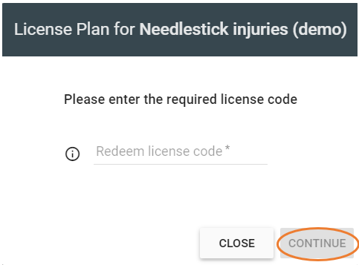
Figure 21
- The status of your study will now change from Building/Testing to Collecting Data.

Amendment Mode
You can make changes to your ongoing study by changing to amendment mode. Data cannot be collected in this mode, so make sure that you plan when to change the study status to amendment mode. However, amendment mode has a number of limitations, due to the changes being made on an ongoing study which might affect the data already collected in the study. Amendments will always affect the whole study (prospectively and retrospectively), so amendments will also apply to already enrolled subjects.

You can perform the following actions in this mode:
- Change any text (Can also be done when not in amendment mode)
- Edit min/max length
- Delete or edit validation rules IF no data has been collected using the form
- Toggle decimal/whole number (will not affect the data already collected)
- Create, edit and delete Reference Rules
- Change 'mandatory' requirements
- Add questions in forms
- Delete questions in forms
  - Note: Deleting questions in forms will remove the data that was collected for those questions. Data can be restored by SMART-TRIAL personnel if removed by mistake.
- Question types can be changed ONLY if no data has been collected using that question
- Change between Dynamic and Static table
- Change order of questions in a form
- Change the process ONLY if there are no subjects enrolled to the site
- i.e. you cannot add or remove data events or change data event order if any subjects are enrolled
- Add/Remove form(s) to/from data event(s)
- Change order of forms in data event
- Create new site and edit site's name and geographical location
- Create new forms
- Create new process
NOTE: You cannot edit possibilities or change question visibility rules on existing questions that have been used to collect data. In such cases you can contact us, as we can perform advanced amendments.

Start Amendment Mode
- Access your study in the study overview
- Click on “Collecting Data” in the top right corner to be redirected to the study overview
- Click on “Study Amendment” in the bottom left corner and type in the study name in capital letters and click “Confirm”. Please see Figure 22.
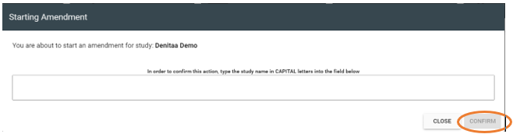
Figure 22
- Your study will change the status from “Collecting Data” to “Amendment mode” in the top right corner.

Finish Amendment Mode
- Access your study in the study overview
- Click on “Finish Amendment” in the bottom right corner and type in the study name in capital letters and click “Confirm”, see Figure 23.
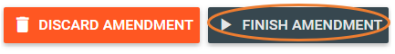
Figure 23
- Your new changes will be applied to the whole study/all subjects and the status will change to “Collecting Data”

Discard All Changes
- Access your study in the study overview
- Click on “Discard Amendment” to discard all changes and revert to the study state prior to starting the amendment.
- Type in the study name in capital letters and click “Confirm”.
- Your study will change the status to “Collecting Data” without applying any of the changes

Closing Your Study
Before closing your study it is important to ensure that the study personnel at each site of your study have access to their data. Data access can be ensured through several ways.

Post Study Archiving for Sites and Sponsors
- The data for the specific sites can be exported and saved on a portable drive.
- Site data can be stored in SMART-TRIAL, as we offer archiving for as long as you want. Data can only be deleted by the study owner meaning that we do not delete any databases. By storing your data in SMART-TRIAL, your sites can access the study at any time through their existing user accounts. The study owner can manage access if new study personnel needs to join the study.
- All eCRFs for each enrollment can be printed out individually and kept at the sites. To print the enrollment:
  - Go to the study overview
  - Click on a subject profile and click “Record History” in the top menu, see Figure 24.
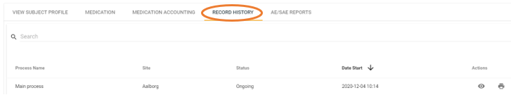
Figure 24
  - Click on the printer icon below ‘Actions’, it might take you a little while to load depending on the number of forms.
  - A new window will appear.
  - Select “Save as PDF” and click “Save”. If you want to print the document, please choose your printer and click on the “Print” button.

End Your Study

Enter your study and click on the “Collecting Data” button in the top right corner to access the study overview.

Click “Finish Data Collection” and enter the study name in capital letters to confirm, see Figure 25.

Click on “Confirm” and your study’s status will change from ‘Collecting Data’ to ‘Completed’
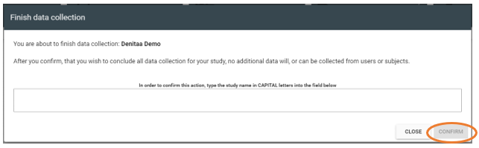
Figure 25

Management of Study Data

Site Overview
This view is used to monitor and manage most of the data collection for a specific site. You have access to an overview of each subject’s process within the study. The site overview includes several indicators and markings that explains the status of data events or some kind of activity associated with the data collection.
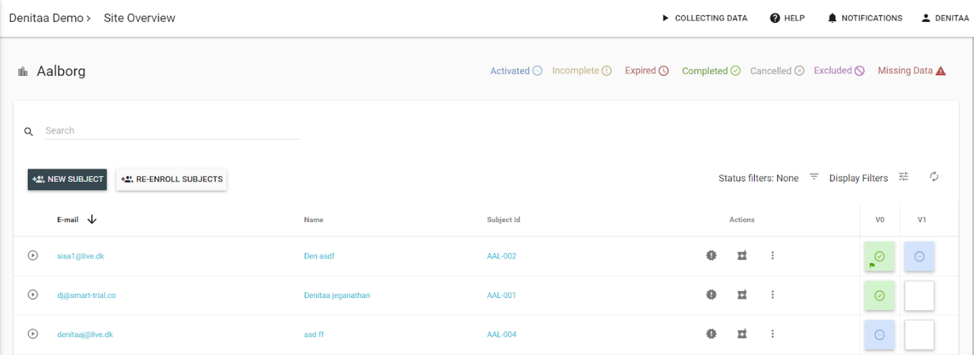
Figure 26
The site overview, see Figure 26, lists each of the sites’ subjects on the left side of the overview, based on your pre-defined subject attributes, for instance with subject id or email. The right side contains a number of data events in the form of squares. These squares can be of different colors with different centered icons.

Data Event Status Indicators
- Inactive: This status indicates an inactive data event and is the status prior to activation. You cannot collect any data when the data event is inactive, and the activation hereof can be selected when the specific data event is added to the process. Please see Figure 27.
Figure 27
- Activated: When this status is available you will be able to access the data event and the attached forms are pending to be answered. It is possible to ‘Lock data event’ in this state. Please see Figure 28.
Figure 28
- Incomplete: This status occurs when a data event has been activated but the forms were partially completed in the form or not all questions or forms being answered. Questions can be either mandatory or optional, and if some of the mandatory questions are not answered, the status for the data event will be incomplete. Please see Figure 29.
Figure 29
- Expired: When creating a data event, it is possible to select an expiration time if wanted. If this status occurs it is due to the expiration of the data event, and it is no longer possible to collect data for that particular data event. You can, however, still edit the collected data if you are permitted the right permissions. Please see Figure 30.
Figure 30
- Completed: This status will appear when all mandatory questions have been answered in a data event. Please see Figure 31.
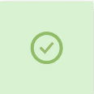
Figure 31
- Cancelled: This status will appear if the subject is discontinued or data gathering is initiated in a data event later in the process allowing the user to select “Cancel previously unused data event”. Please see Figure 32.
Figure 32
- Excluded: If a patient does not meet the inclusion or exclusion criteria of the study, the patient will get excluded. Please see Figure 33.
Figure 33
- Missing data: It is possible to add additional questions on an ongoing study by changing the study status to “Amendment mode”. The data event containing the new question will have the missing data indicator, for all subjects who have already completed the original form prior to changes. Please see Figure 34.
Figure 34

Data Event Additional Markings

Missing data: This marking appears if a data event contains forms with missing data due to a question being marked as ‘Answer Not Available”. Please see Figure 35.

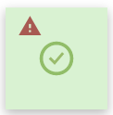
Figure 35

Locked: If a data event is locked, it is not possible to change the answers. Lock and unlock of data events requires specific permissions. Please see Figure 36.

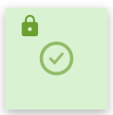
Figure 36

Verification: This is a tool that allows monitors, sponsors or data managers to mark the data as verified. SMART-TRIAL provides two types of verification (I + II) and these can be used for the purposes that your study chooses. The images illustrate a fully and partially verified data-event for the two types. The partial verification applies when some of the questions are verified or if only one of more forms are verified within the specific data event. Please see Figure 37.

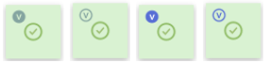
Figure 37

Query: This marking appears if a data event contains an open or responded query. Please see Figure 38.
Figure 38

Filters
You can use filters in the site overview to display or hide certain subject information or data events. The filters can be accessed in the right corner of the site overview, see Figure 39.
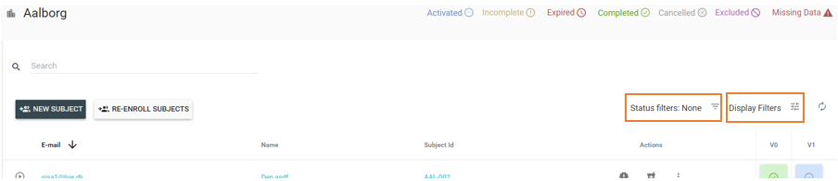
Figure 39
- Status filters: The status filter filters subjects based on the status of enrollment; show only ongoing, discontinued, completed or excluded subjects. You can also apply a combination of these.
- Display filters: Use this filter to add/hide information of status icons, subject attributes and unscheduled events. This filter enables you to create a well-arranged and relevant site overview.
  - Status icons: Answer not available, Lock, Open/Responded Query, Verification I and II.
  - Subject attributes: Subject ID, Name, Initials and E-mail address.
  - Unscheduled event: Highlight unscheduled events.

Change Answers
You can change already entered answers if the “Enter/Edit” permissions is granted in the collaborators overview. To change answers:

- Access the site of interest by using the left-side menu.
- Click on the data event containing the form answers you want to edit, and select “View Form Answers”, see Figure 40.
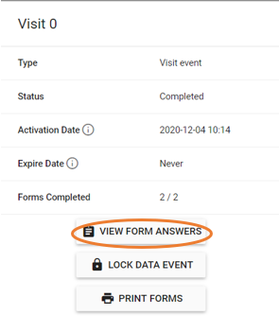
Figure 40
- If all mandatory questions were answered and all forms completed, you can click on “Edit Answers” in the upper right corner. The button activates editing mode enabling you to edit the form answers. Please see Figure 41.
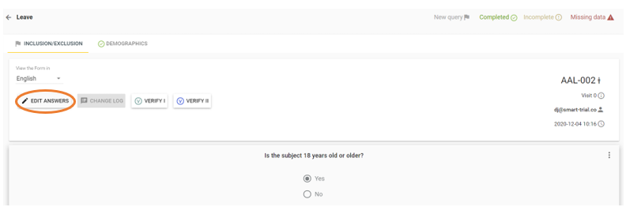
Figure 41
- To save the edited form answers, click “Update”.
- Give a reason for changing the answer
- If you do not want to save the updated answers, click on “Discard Changes”

Change Log
SMART-TRIAL keeps track of all changes and actions performed on the forms in a Change Log. Information on when, by who and a reason behind the change is stored and can be accessed by clicking on the data event of interest, selecting “View Form Answers” and clicking on the “Change Log” button in the bottom of the window. Please see Figure 42 and Figure 43.

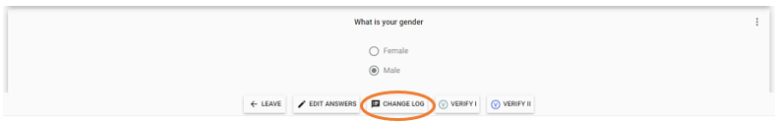
Figure 42
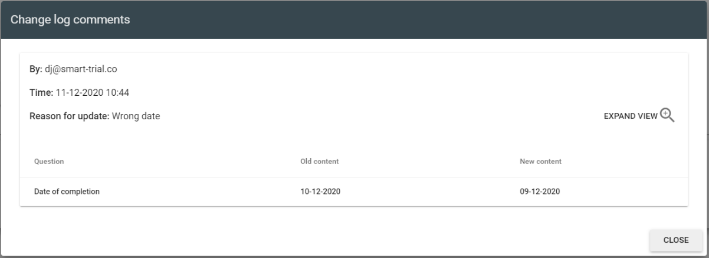
Figure 43

Verification
This is a tool that allows monitors, sponsors or data managers to mark the data as verified. SMART-TRIAl does not have a predefined meaning for the use of verification. It is therefore possible to apply ‘verification’ in any way that makes sense for the study. SMART-TRIAL provides two types of verification (I + II), working exactly the same way, and these can be used for the purposes that your study chooses. Examples on verification could be: Monitored, Source data verification (SDV), or reviewed. The verification tool could be useful when study personnel with different roles have to verify the data independently of each other. The verification tool can be named when setting up the study or when editing an already existing study in the study overview.
Any collaborator with verification permission can verify and unverify the following data:
- Individual questions (Regular and unscheduled events)
- Entire forms (Regular and unscheduled events
- AE reports
- Medication
- Medication Accounting
The verification status will be shown with either a green or a blue marking in the site overviews. In the overview of a specific data event, the top bar shows the forms included in the data event and which of these forms are partially and fully verified, see Figure 44.
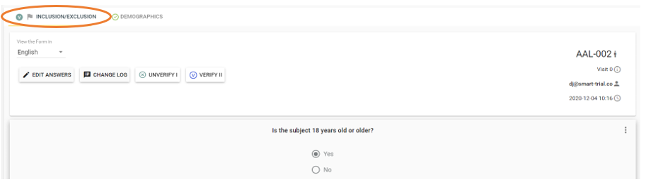
Figure 44

Full and Partial Verification
Verifying a single question in a form, will mark both the form and the data event as partially verified. Verifying all questions in a form will mark the form as fully verified. All forms within a data event must be fully verified before the data event is marked as fully verified. If an answer is edited after the form has been marked as verified, both the data event and the form containing the edited answer will change from fully verified to partially verified until the new answer has been verified again.

How to Verify
- AE reports can be verified by clicking on “View the full report”. AE reports can only be fully verified.
- Questions and forms can be verified by clicking on the specific data event of interest and selecting “View form answers”
- You can verify individual questions by clicking on the three dots (remote monitoring) of a question and clicking on the verify icon, see Figure 45.
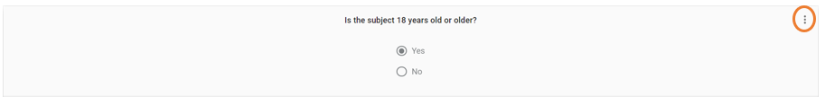
Figure 45
- Medication and medication accounting can be verified from the list view and can only be fully verified.

Verification Statistics
It is possible to view verification statistics for verified data events. This is performed by clicking on the verified data event. The new window will state the percentage of verification in the bottom of the window. The percentage is calculated based upon the level of verification for each form within the data event and it does not relate to the number of questions in each form.
- Click on the individual verification percentages to view the last person who verified a question or a form in the data event, see Figure 46.
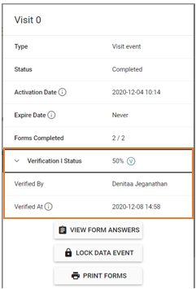
Figure 46

Queries
Queries can be used by investigators and monitors to raise queries on already collected data in case they find something strange or missing values or answers. Queries can be created in any saved form (AE, Image chart and regular form) and wherever they are used (Data event, Unscheduled event, Adverse event module).

Create Query
You need to have specific permissions granted in order to create queries.
- If you want to create a query in an incomplete data event (Not all forms were completed or not all questions in the forms are answered), ensure that you do not have the “Enter/Edit” permission but have the ‘Query’ permission enabled. If the form is completed you can create a query while having the “Enter/Edit” permission granted.
- Click on the data event of interest and select “View Form Answers” to be redirected to the form answers.
- Click on the three dots which are found on the top right of each question/answer, see Figure 47.
Figure 47
- Select “New Query” and type in your query.

View Query
There are three ways of viewing af query:
- Notifications: When a new query is created you will be notified by the bell in the top right corner (if you have the data entry permission granted). If you click on the query notification you will be redirected to the respective form and query. Please see Figure 48.
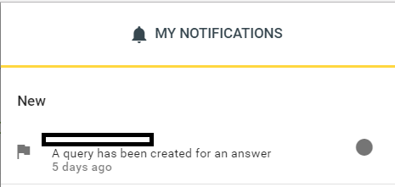
Figure 48
- Site overview: You can access created queries through the site overview since open queries will be visible as small flags placed on the data events. Click on the relevant data event and select “View Form Answers”. You can select the form with a query (flag) in the top bar. Queries can be seen below the related question, see Figure 50 and Figure 50.
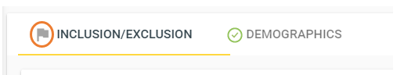
Figure 49
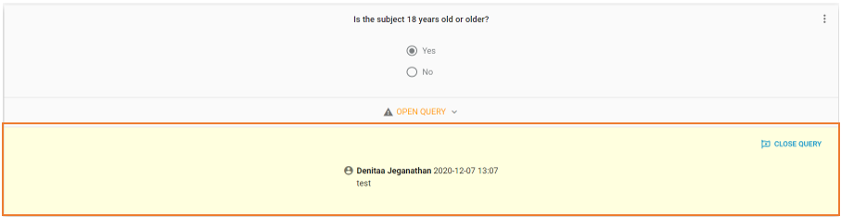
Figure 50
- Query list: You can view all queries by using the left-side menu and clicking on “Queries” which will bring you to a query overview. Click on “Go to form” which is the first icon below ‘Actions. You can add filter options in the queries overview to sort the queries if needed. You can sort the queries based on who the queries are created by, the status of the queries (open, responded, closed), subject, sites, data events, specific forms or search for a specific query text. Please see Figure 51.
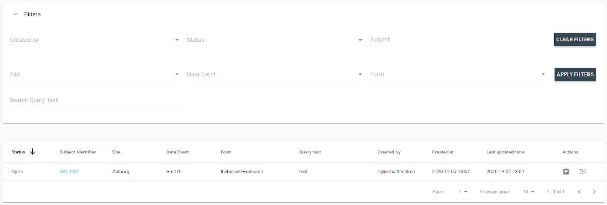
Figure 51

Respond Query
To respond to a query, access the query using one of the above mentioned methods. You can choose to respond with or without change. If you choose to “respond with change” the question will open for editing, click submit when you have made your changes to respond to the query. You can also choose to decline the query by clicking “Respond without change” and give a reason for declining the query. The correspondence continues until both parties are satisfied with the answers. Please see Figure 52.
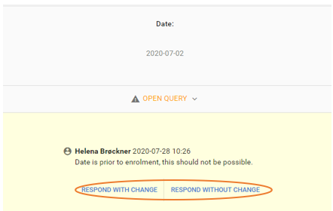
Figure 52
NOTE: It is only possible to respond with changes to queries on questions you have permission to answer. E.g.: Only users with “Sponsor Permissions” can respond to sponsor specific questions in an AE report.
NOTE: You cannot respond to your own query!

Lock/Unlock Data Events
Forms can be accessed and changed by staff as long as data events are not locked. You can secure answers/data in a data event at any time by locking the data event. This means that no data can be changed or edited. You will, however, need the “Lock” permission in order to be able to lock and unlock data events. A locked data event will have a little lock icon in the top right corner of the data event. Remember not to lock any data events before all sites have collected data.

To Lock Data Events
- Click on the specific data event you want to lock in the site overview.
- Select “Lock Data Event”, see Figure 53.
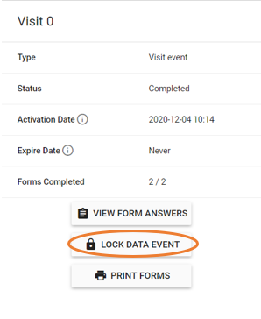
Figure 53
- Type in your password for SMART-TRIAL to confirm lock of data event.

To Unlock Data Events
- Click on the specific data event you want to unlock in the site overview.
- Select “Unlock Data Event”´, see Figure 54
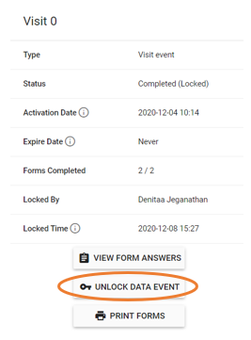
Figure 54
- Type in your password for SMART-TRIAL to confirm unlocking the data event.

Sign Off Enrollment
By using this function you lock every single data event for a specific subject. The answers cannot be changed and the time and name of the person who signed off the enrollment will be available. The function is most often used by investigators in late stages of the study, since it locks all data events and signs off. To sign off enrollment:
- Go to the site overview of interest.
- Click on the three dots below ‘actions’ aligned with the specific subject, see Figure 55.
Figure 55
- Click “Sign off Enrollment” and enter your password to confirm

Remove Data
It is possible to remove AE/SAE, medication and unscheduled events from an ongoing study with the permission “Remove”. Removed items will be moved into “Storage” and will not be a part of the export or visible in the regular study. To remove click on “”.
- Unscheduled event: Click on the unscheduled event marking in the site overview and select the remove icon, see Figure 56.
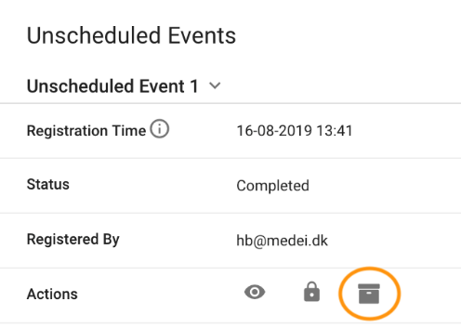
Figure 56
- Medication: Click on the medication icon via the site overview, find the medication you want to remove and click on the remove icon, see Figure 57.
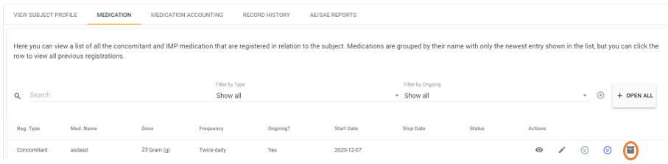
Figure 57
- AE/SAE reports: Click on the AE/SAE report icon via the site overview or access through the Subject profile. Select “AE/SAE Reports” in the top bar and click on the remove icon for the AE/SAE report of interest, see Figure 58.
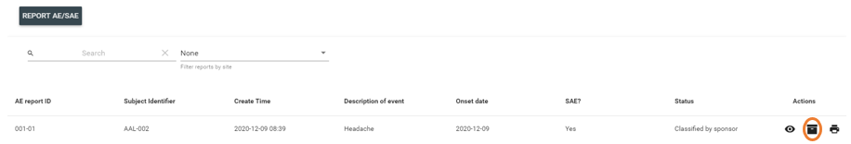
Figure 58

Access the storage menu by using the left-side menu. You can sort your list by site or element type (AE/medication/unscheduled event). You can restore items by clicking on the restore icon (arrow), see Figure 59. Confirm the restoration by clicking yes in the prompt.
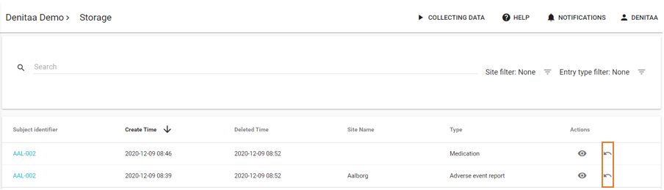
Figure 59

Data Overview
You can get an overview of the population and a status of subjects in relation to the number of enrolled, ongoing, completed, discontinued, excluded and withdrawn subjects in the data overview. Access the data overview by using the left-side menu and click on “Data”. You will be redirected to an overview presenting some statistical data on the population. You can view the status of subjects by clicking on the “Status” in the top bar. The data overview also allows you to filter the overview by site or answer. Please see Figure 60.
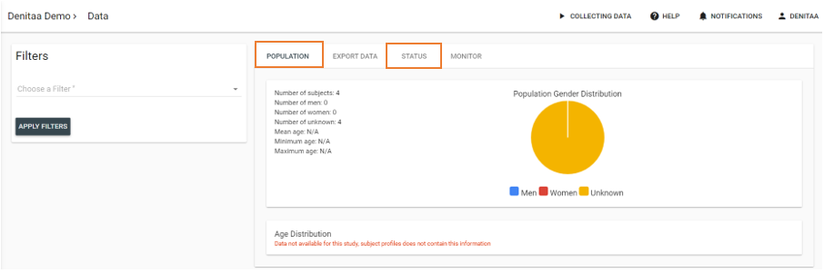
Figure 60

Export Data
To export data it requires specific permissions which can be granted in the collaborator overview. Enter the export overview by using the left-side menu and click on “Export”. For security reasons you will need to authenticate with a one-time password by clicking on the “Request Password” button. Type the 4-digit code received by SMS and click “Verify Password” to enter the export overview, see Figure 61.
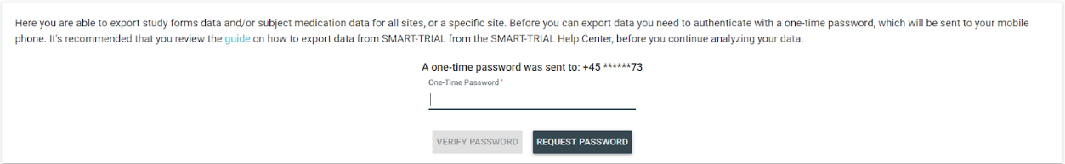
Figure 61
- Select which data you want to export in the first selector, for instance the scheduled events including all data events.
- Secondly, select the desired date and time format
- The input that should be available in the export header is already pre-selected to include data legends, to make the export easier to read, and custom export labels. In case you do not have custom export labels, the export file will automatically contain SMART-TRIAL’s export labels.
- Choose if you want to export data for all sites or for specific sites.
- Select which subject attributes you wish to include in the export, such as subject id or e-mail address.
- Lastly, select whether the export should use coded (yes = 1) or text (yes = yes) possibility answers.
- Click on the “Export Data” button to generate your export file, see Figure 62. This may take up to a few minutes depending on the size of your study. The exports will be shown in the export list after generation is completed. The user will be notified when the export is ready in case the user does not remain in the export view.
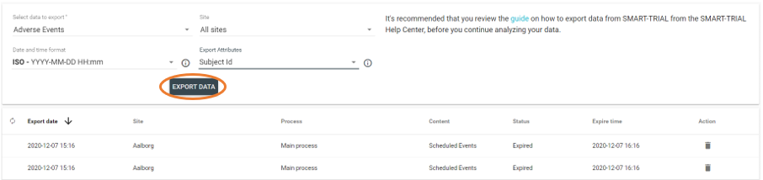
Figure 62
- Click on the requested file to fold out the options for the file.
- Click on the download button, see Figure 63.
Figure 63
NOTE: Exports are stored for one hour after generation of the file.

One export file will be generated for each process created. These cannot be assembled as the processes can be very different. The export file will be generated as a csv file which can be imported into Microsoft Excel or other data programs of interest.

Where to Store Exported Files
It is important to be aware of where the export is stored after downloading the files due to security reasons. Therefore, investigate how you store data internally and choose the option that is most suitable for det purpose, for instance a secure common drive.

Audit Log
All user actions will be stored in an audit log. SMART-TRIAL provides one independent audit log for each study. You can access the audit log by using the left-side menu, if you have the audit log permission. This permission should only be granted to collaborators who may need to look back in time and who are allowed to see study data and personal identifiable information as the audit log contains all information.
It is possible to filter the audit log by four categories: Subject, Actor, Model and Operation. To see the specific actions for these four categories, click on this link: https://help.smart-trial.co/display/HELPPlayground/Audit+log. Please see Figure 64.
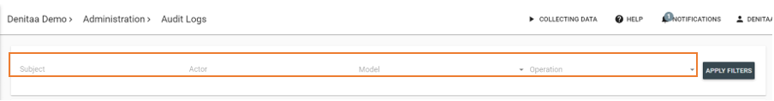
Figure 64

Actions in Audit Log
It is possible to do two types of actions in the audit log, “View Difference” and “Go to Object”.
- “View Difference” will display the object before and after an edit or change.
- “Go to Object” will redirect you to the object (subject, form etc.). This action may, however, fail if the object no longer exists due to the object being inactive or deleted.

Export Audit Log
To export an audit log, please contact the SMART-TRIAL support team since exporting of the audit log is quite time consuming due to the size of it

Study Notifications
Study notifications is an add-on which allows you to implement different listeners that will be triggered by specific events such as when a new subject is enrolled, subject is randomized, AE/SAE is created, system generated query, and when the study is amended. When triggered by one of the aforementioned events, the event will either send an email to specified email addresses or a HTTP POST to a specified end point. The specified users behind the emails will always receive an email if the event occurs. Please see Figure 65.
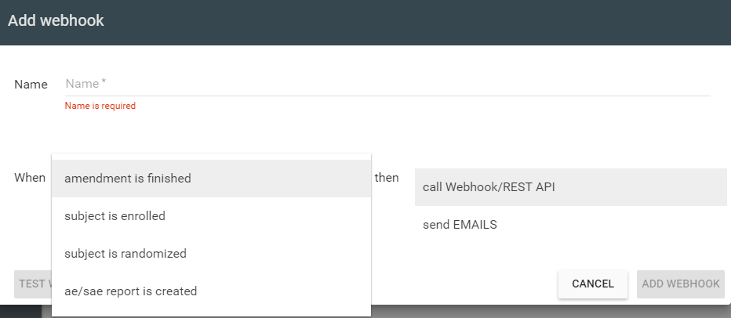
Figure 65

Management of Subjects
There are two options for removing a subject from your study, you can either discontinue or exclude a subject.

Discontinue Subject
If you choose to discontinue a subject, you will not be able to reverse the subject to the study. The previous collected data for the specific subject will remain unaffected but the subject will not be a part of the study.
To discontinue a subject:
- Enter the site of relevance by using the left-side menu.
- Find the subject you want to discontinue and click on the three dots below ‘Actions’, see Figure 66.
Figure 66
- Select “Discontinue” and click on “Discontinue Subject” in the subject status, see Figure 67.
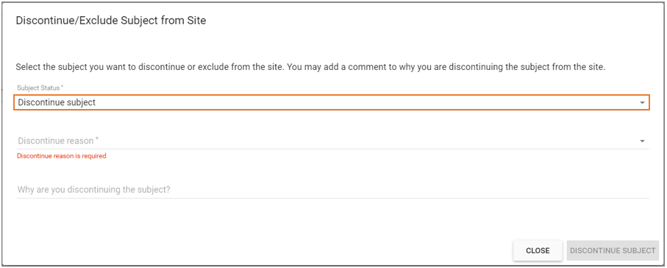
Figure 67
- Select the reason for discontinuing the subject and add a detailed comment if desired.
- Lastly click on the “Discontinue Subject” button.
- The data events for the specific subject will turn grey, see Figure 68.
Figure 68

Undo Discontinue Subject
You can re-enroll a subject if you regret discontinuing a subject. The site overview will still contain the discontinued subject with all the previous entered data. Re-enrollment of a subject will not cause the data events to begin from where they were before discontinuing. You will have to manually disable any prior data events and activate the relevant data events.

To undo:
- Enter the site of interest by using the left-side menu
- Click on the “Re-Enroll Subject” button in the top, see Figure 69.
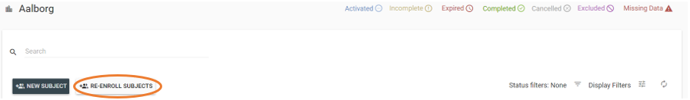
Figure 69
- A new window will open and here you can select the discontinued subject(s) you want to re-enroll to the study. Please see Figure 70.
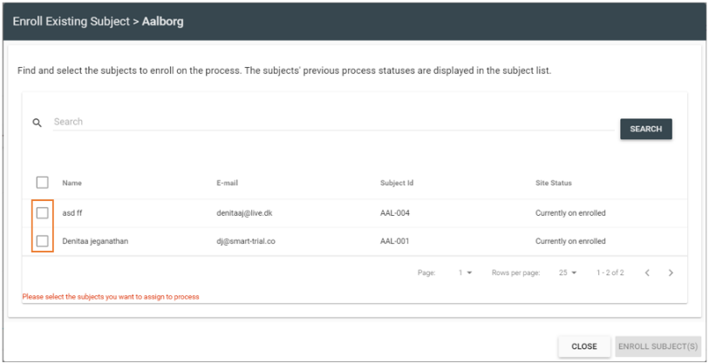
Figure 70
- Click “Enroll Subject” in the bottom right of the window.
- The re-enrolled subject will be visible in the site overview

Exclude Subjects
- Enter the site of relevance by using the left-side menu.
- Find the subject you want to exclude and click on the three dots below ‘Actions’, see Figure 71.
Figure 71
- Select “Discontinue” and click on “Exclude subject” in the subject status, see Figure 72.
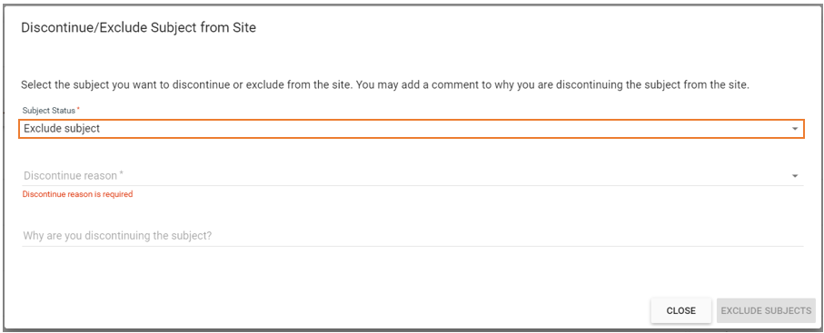
Figure 72
- Select the reason for excluding the subject and add a detailed comment if desired.
- Lastly click on the “Exclude Subject” button.
- The data events for the specific subject will turn purple, see Figure 73.
Figure 73

Undo Accidental Exclusion
It is possible to reverse an accidental exclusion of a subject.
- Enter the site of interest by using the left-side menu.
- Use the “Status Filter” to view the “Excluded” subjects.
- Click on the data event containing the inclusion/exclusion form and select “View form answers”
- Select “Edit answers” in the top left corner, see Figure 74.
Figure 74
- Find the question which the exclusion was based on and edit the answer to cause inclusion of the subject
- Click on “Update” in the bottom of the window and enter the reason for updating the answer.
- The patient will now be included in the study.

